- Select a systematic sample of size:
  - 10 from the class.
  - 6 from the class.
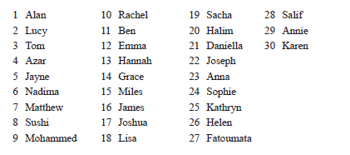

- There are 400 trees in a plantation. All the trees have been planted in rows. Describe how to create a systematic sample of 25 trees.

- The houses in a street are numbered from 1 to 340. Describe how to create a systematic sample of size 20.

- Explain why a systematic sample is not a random sample.

