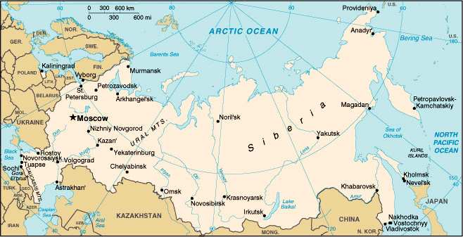

How big is Russia?

Give me 5 facts you have researched on Russia.

