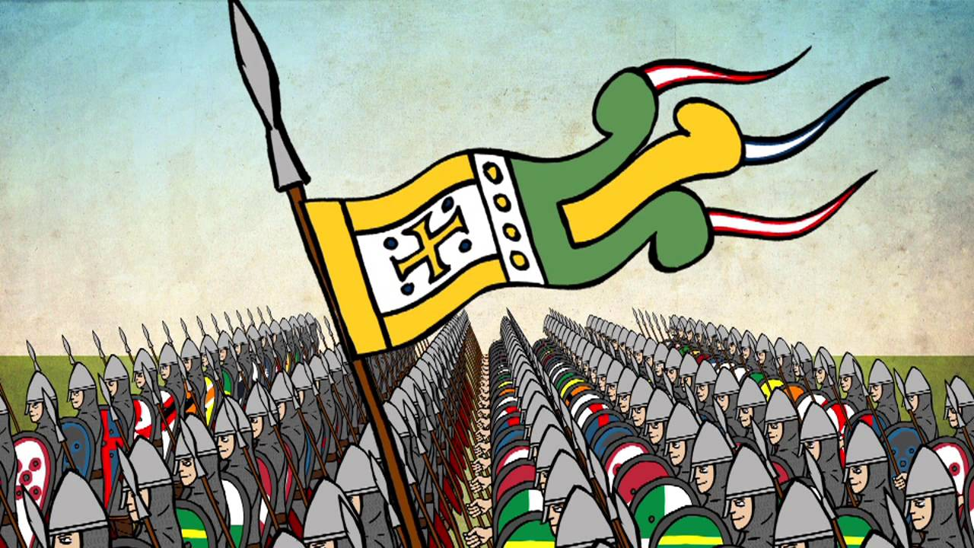  1 | 2 | 3
On 14 October at around 9:30 in the morning, the Battle of Hastings began …

4  5 |  | 6

