Medieval Realms: Why did William, Duke of Normandy, become King of England in 1066?

Resources: Textbook p.10-15
Video programme: William the Conqueror

On 5th January 1066, Harold Godwinsson was crowned King of England. However, would Harold be able to hold on to his new crown?

DISCUSSION POINTS: (1) Why do you think Harold was able to become king instead of the other two claimants?
(2) Why do you think 1066 was going to be a year of two foreign invasions?

Put the above main title in your book and then the following subtitles:

Harold’s Problem Number 1: How would he defend England against two invasions?
Read p.10 and 11 including sources 10 and 11. Answer question 1 on p.11.

Harold’s Problem Number 2: How would he defeat Harald Hardrada?
Read p.11 and source 12. How was Harold able to defeat Hardrada?

Harold’s Problem Number 3: How would he defeat Duke William?
How would you assess Harold’s position on 27 September 1066? Was it stronger or weaker than before Hardrada’s invasion? Answer carefully.

On the eve of the Battle of Hastings 14 October 1066, who would be best prepared for battle – Harold or William? Use p.12-13, including Sources 1-4 and the handout timeline, to help you answer carefully.

DISCUSSION POINT: On the day battle was to commence, do you think Harold had any chance of winning?

Put the following subtitle:

The Battle of Hastings – What happened?

Take a double side of your book and on one side put ‘A Norman account – William of Poitiers’; on the other side put ‘An Anglo Saxon account – The Anglo Saxon Chronicle’.
From reading sources 7 and 8 from p.14, tell the story of the battle in your own words under the appropriate heading.

What are the key differences in each account? Can you explain this? Explain.

DISCUSSION POINT: Do you think there were any moments in the battle when Harold could have won?

How was Harold killed?
FINALLY… draw your own version of his death based on what you have found out (URRGHH!). Use colours!

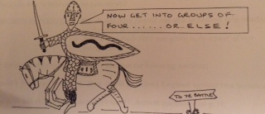

SOURCE INVESTIGATION: THE BAYEUX TAPESTRY – WHAT IS IT GOOD FOR?

The Bayeux Tapestry was made to commemorate the battle a few years later. It tells the story of the battle (and events before) as a sort of ‘woven picture strip’. It is quite unique and justifiably famous. You have in front of you sections taken from the tapestry.

- Lay out the sections in chronological order. Do not follow the alphabet – they are all mixed up. They are random sections so do not look for joins!
- Now fit the captions to the sections (the captions are also jumbled up).
- In rough as a group, how far does your version ‘fit’ with what you already know of the battle and what happened? What problems have you found in using this evidence? Do you think we can trust this as a reliable source about the battle?

Write down your observations as a group (one person can write, the others can contribute). Be prepared to report back to the class.

What else can the tapestry tell us?
Study the picture sections and note down (a) what else this tapestry is good for apart from telling the story of the battle and (b) what questions you would like to ask about the tapestry to help you to understand it better. For example;
What do the borders of the tapestry show (especially on sections E, F, G, H and I)?
What weapons are being used and who uses them?
What else is on the tapestry that helps us understand what the pictures are telling us?
In what ways does it help us understand what early medieval warfare was like?

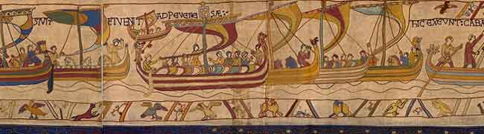
A

B
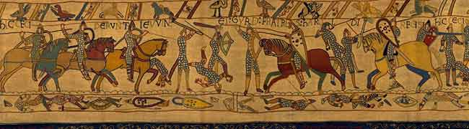

C

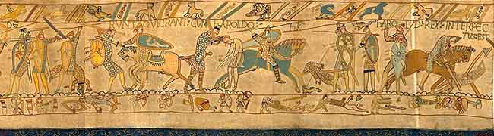

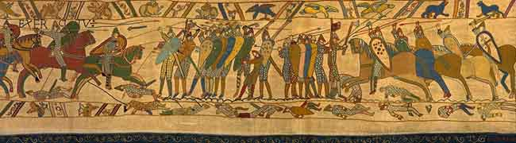
D

