The Norman Conquest
You are writing a double-page spread for a school textbook to explain the Norman Conquest to nine-year-olds. You have been told that you only have room for 300 words and that you need a large map which you will illustrate.
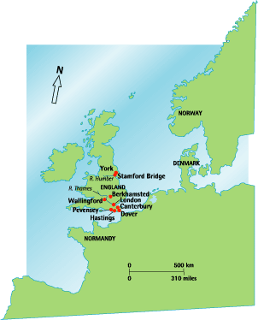
- Your design department has produced a map, but it is not very interesting. So you need to improve it. Take a piece of clean paper and copy the map.
- Now write your account. Cover:
- threats to King Harold from overseas
- events of September and October 1066
- William’s route to London
3. Go back to your map and improve it by adding arrows, labels and short pieces of information in boxes.

