Barons
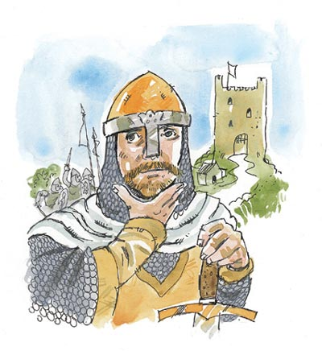
- Why were the barons more likely to rebel against William than against Edward the Confessor?
- One reason for the ‘Harrying of the North’ was to discourage further attacks by Danes or Norwegians on northern England. Why did William think this would work?
- What other reasons might William have had for the ‘Harrying of the North’?
- Why do you think William changed the way he treated the barons?
- After 1070 there were very few rebellions and from 1073 onwards William spent most of his time in Normandy. What does this tell you about William’s control over the barons:
(a) between 1066 and 1070?
(b) after 1070?
- How did William control England?
- What were the problems and challenges?
- What did William do to solve the problem?
- How good was his solution?
- Were there any disadvantages?
- Write a letter from William to his brother, Odo. Tell him about the gift of land to your fellow Normans and why you have done it. Tell him what other actions you have taken with the English barons and why.
- What might Odo have said in reply? Remember he might have thought William’s treatment of the barons would not work, and he would want to warn him of dangers.

