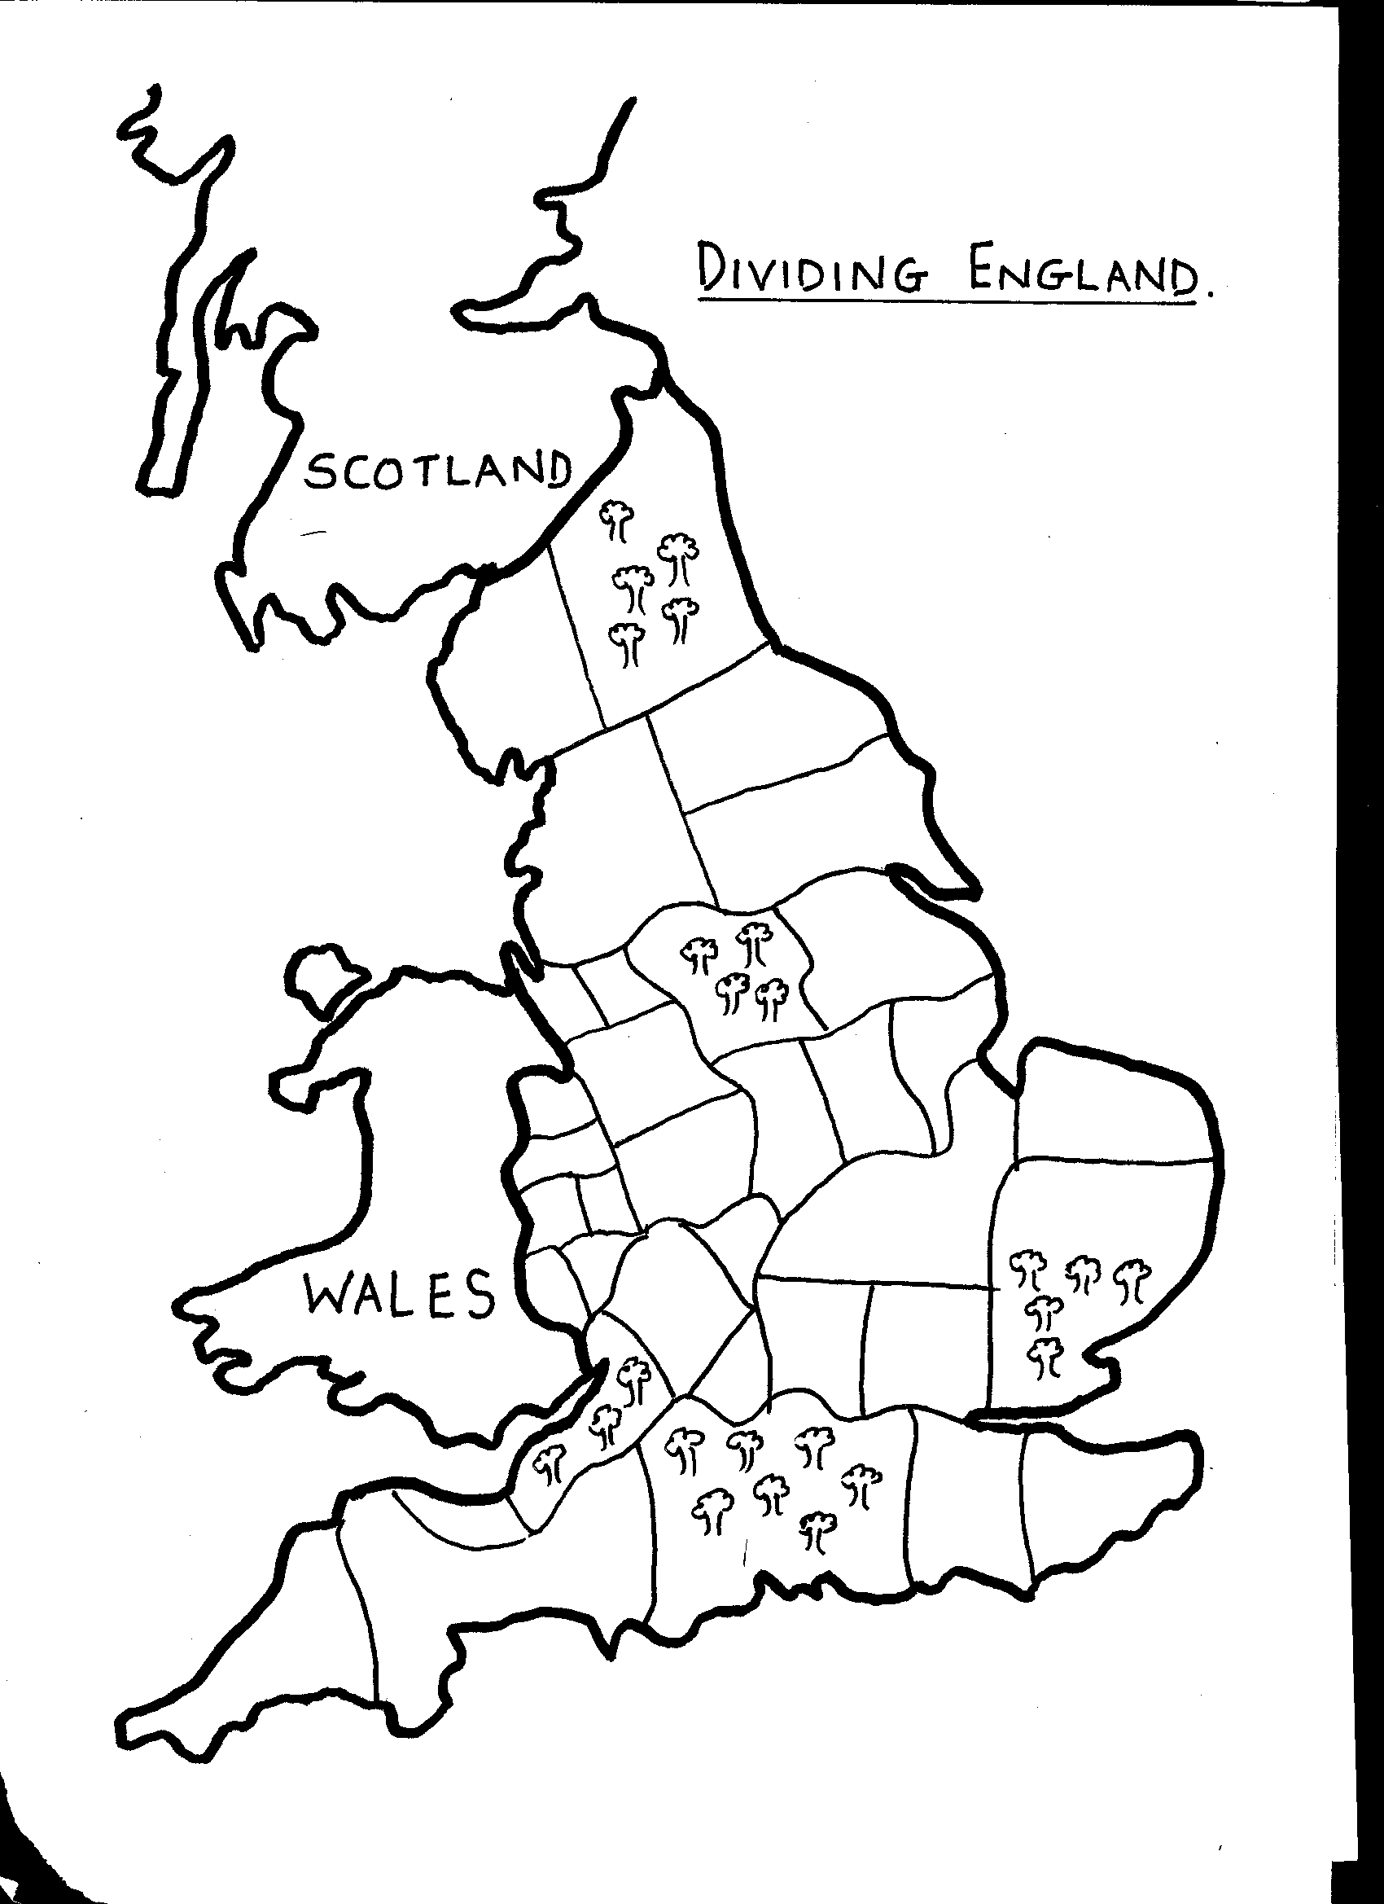

KING WILLIAM
THE CHURCH
BARON A
BARON B
BARON C
The king has ¼ of the land. The Church must have ¼ of the land. The Barons must have the rest shared between them. The king needs to keep the forests. Nobody is allowed to have 2 bits of land together.

