Attacking a Motte & Bailey Castle

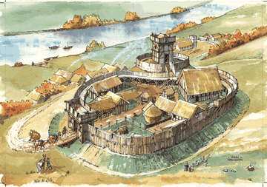

Q. How would you successfully attack the castle?
___________________________________________________________________________________________________________________________________________________________________________________________________________________________________________________________________________________________________________________________________________________________________________________________________________________________________________________________________________________________________________________________________________________________________________________________________________

