Attackers and defenders
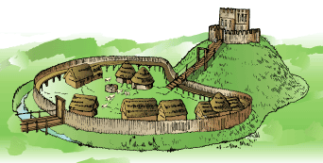
An artist’s reconstruction of a motte and bailey castle.
Divide the class into ‘Attackers’ and ‘Defenders’.
Look carefully at the drawing of the motte and bailey castle.
DEFENDERS:
1. Make your own drawing of a motte and bailey castle. Label it showing the different parts and what their purpose was. Use these questions to help you:
- Why was the motte a steep hill?
- Why was there a tower on top of the motte?
- What were the towers for?
- Why was there a drawbridge?
- Why did the motte have a wooden staircase up it?
- What was the moat for?
- Why did the bailey have a high wall around it?
- Why was there a well?
- Why were animals kept in the bailey?
2. What makes a motte and bailey castle easy to defend? Make a list.
3. How might a Norman baron, in charge of defending the castle, react? It is 1070. He has heard rumours that a group of hostile Englishmen is on its way to attack him.
(a) What plans do you think he might have made to defend the castle?
(b) How would he have made sure of food and water? He could have been held siege for weeks!
(c) How would he have defended himself if attacked with arrows, battering rams, fire, catapults?
(d) How would he have known when the English had arrived?

ATTACKERS:
1. Make your own drawing of a motte and bailey castle. Label it showing the different parts and what they did. Use these questions to help you:
- Why was the motte a steep hill?
- Why was there a tower on top of the motte?
- What were the towers for?
- Why was there a drawbridge?
- Why did the motte have a wooden staircase up it?
- What was the moat for?
- Why did the bailey have a high wall around it?
- Why was there a well?
- Why were animals kept in the bailey?
2. What makes a motte and bailey castle hard to attack? Make a list.
3. How might an English baron, in charge of attacking the castle, react? It is 1070.
(a) What plans would he have made to attack the castle?
(b) How would he have made sure of food and water? He could have been there for weeks!
(c) How would he have used arrows, battering rams, fire, catapults to attack?

