The Domesday Book
- Read what each of the historians wants to find out about. One of them has made a big mistake and the Domesday Book will not help. Which one has made a mistake?
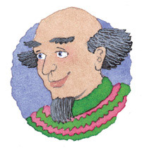 | I want to find out how poor people were in the past.
I want to find out what houses were made out of in the past. | 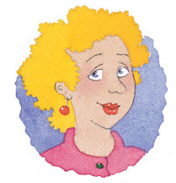
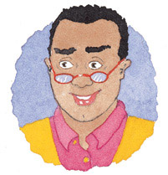 | I want to find out how many people lived in England in the past.
I want to find out how damaged England had been by the Norman Conquest. | 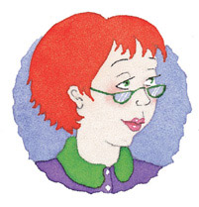

- Explain how the Domesday Book could help each of the other three historians to answer their big questions.
3. What other historical questions could the Domesday Book help to answer?
The Domesday Book can also be used to find out about changes in the ruling class after the Norman Conquest. Historians have used it to count the number of foreign knights. In 1086 there were about 2000 out of a total population of 1.5 million. By 1086 all the barons were Norman. Therefore, at this time England was ruled by a very small and very rich ‘foreign’ ruling class.
4. Read the two statements below and decide which statement you agree with most.
The Domesday Book shows us that William had very good control of England. It could not have been written if he had not.
The Domesday Book shows us that William did not have good control of England. It would not have been needed if he had.
5. Can you think of anything else you have found out about William which you could use to support your chosen statement?

