A medieval doom painting

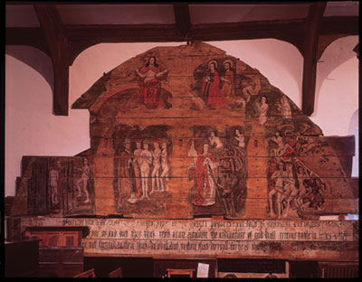
© Sonia Halliday
A medieval doom painting.

- What is happening in the doom painting? Why is it called a doom painting?
- How might ordinary medieval people react, seeing this painting nearly every day of their lives?
- Why did pictures like this ‘doom painting’ play such an important part in the life of the medieval church?
- Use the extract from the Venerable Bede’s sermon below to make a doom painting of your own.

From A History of the English Church and People written around ad 730 by the Venerable Bede. It is part of a story told by a man from Northumbria who thought he had returned from the dead.
To our left was dreadful with burning flames while the opposite side was equally horrible with raging hail and bitter snow blowing and driving in all directions. Both sides were filled with men's souls which seemed to be hurled from one side to the other by the fury of the tempest. Some dark spirits came from the fiery depths and terrified me with their glowing eyes and foul flames coming from their mouths and nostrils. Then my guide took me along a road to the right and brought me out of darkness into clear light. I saw a broad and lovely meadow flooding with light. In the meadow were many men in white robes and groups of people happily sitting together. And as my guide led me through the crowds of happy citizens, I began to wonder whether this was the Kingdom of Heaven.
- Explain how the medieval Church tried to control what people believed in and what they did.

