How did the medieval church affect people’s lives?

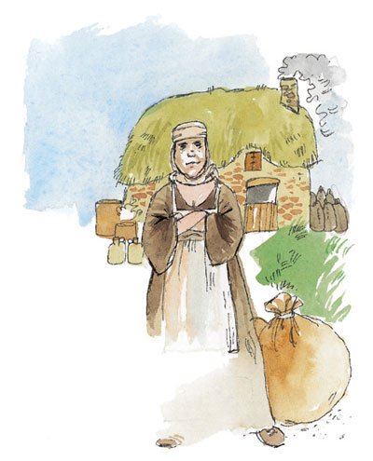

Maud the Brewer
Lives in a small village
Widowed with three children
Finds it hard to pay tithes
A grumbler

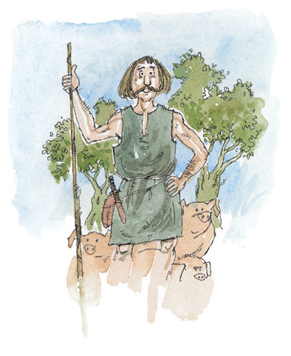

Garth the Pig-man
Works for a harsh lord of the manor
Unmarried and parents dead
Goes to church frequently
Always looks on the bright side

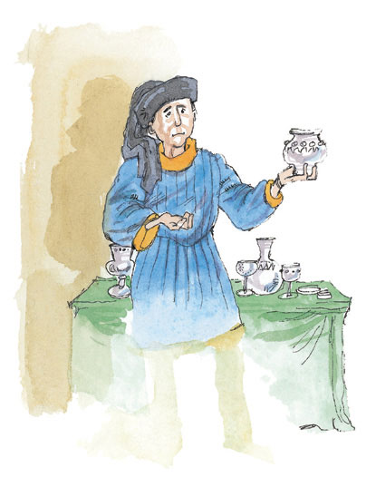

John the Silversmith
Lives in a large town
Married with four children
Has been on a pilgrimage
A worrier

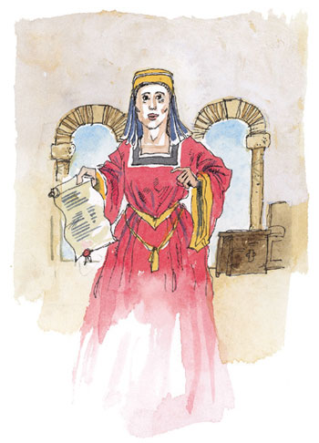

Clara the Businesswoman
A successful businesswoman
Rich – widowed twice
Gives to churches and monasteries
A careful planner

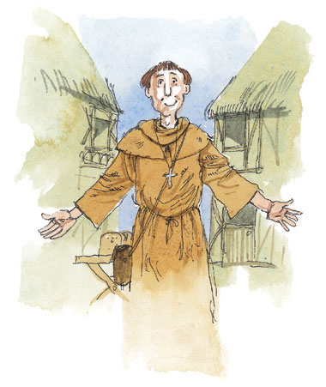

Dominic the Friar
Preaches in markets and fairs
Unmarried
Does not want any possessions
Quietly hopeful
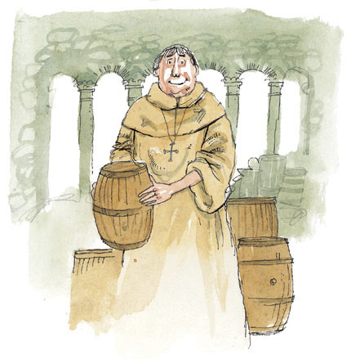

Wilfred the Monk
A Cistercian monk
Works as a cellarer
Helped make his monastery rich
Ambitious
Choose one of the characters above.
How would the person you have chosen answer the question ‘How has the Church affected your life?’

