The impact of the parish church on people’s lives
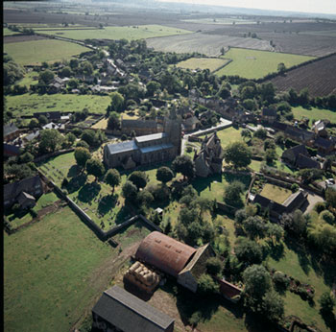
A modern photo of Lyddington village showing the dominant position of the church.
- Look the picture of the parish church above. Make a list, using only the picture, of the reasons why the church seems to be the most important building in the village. What does this tell us about the ways in which medieval people regarded the Christian religion?
- Read about the different ways in which medieval people used their church buildings. For each activity, say where it would be held today. Why have all these activities moved out of the church building?
- Research ‘rites of passage’ in the Christian religion and in the Jewish, Muslim and Hindu faiths. What are these rites? In what ways are they similar in all four faiths? Why are they important?

