The Christian Church in medieval times
- What conclusions can you draw about Christianity in medieval times from
(a) the building and sites of Durham Cathedral and Castle and
(b) the Prince-Bishops of Durham?
- Do some research to find out where the medieval churches of St Magnus Kirkwell, Hagia Sophia, Santiago de Compostela and the Church of the Madeleine are located and label them on the map.
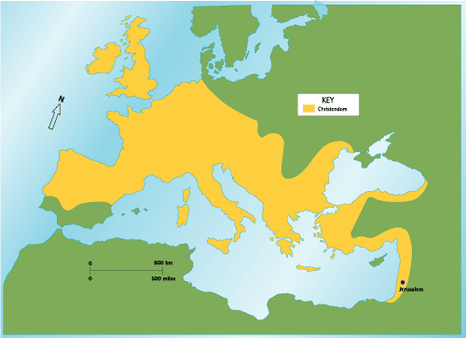
- Go and look at your local parish church. When was it built? If it wasn’t built before about 1500, find the medieval church nearest to where you live. Does it look anything like the pictures of medieval churches you put on the map of Europe? Can you start working out why it might have been built where it was?
- Why were churches built bigger than they needed to be to hold all the people in a parish?
- Research to find out why churches were built in the shape of a cross and why the altar was always at the east end of the church.

