Medieval abbeys

The ruins of Rievaulx Abbey.

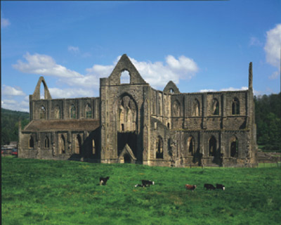
© A F Kersting
The ruins of Tintern Abbey.

Choose ONE of the buildings. Find out when it was built, where it was built, by whom, and why, it was built.
Compare what you have found out with what others in your class have found out about that building and the other buildings. Build up an information database to which you can add later.

