The parish priest
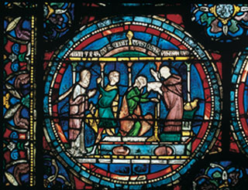
© Sonia Halliday
A stained glass window image of a priest treating the sick.
- What different kinds of work did a medieval priest have to do? Make a spidergram, with the priest in the middle.
- What personal qualities should a medieval priest have? Should he, for example, be cunning or straightforward, kind or strict, clever or simple? Make a second spidergram, linked in with the first one.
- Use both these spidergrams to work out what advice a father might give to his son who has just told him he wants to become a parish priest. Write out what their conversation might be.
- Why do you think that some priests fell below the standards expected of them?

