Writing to a Monastery
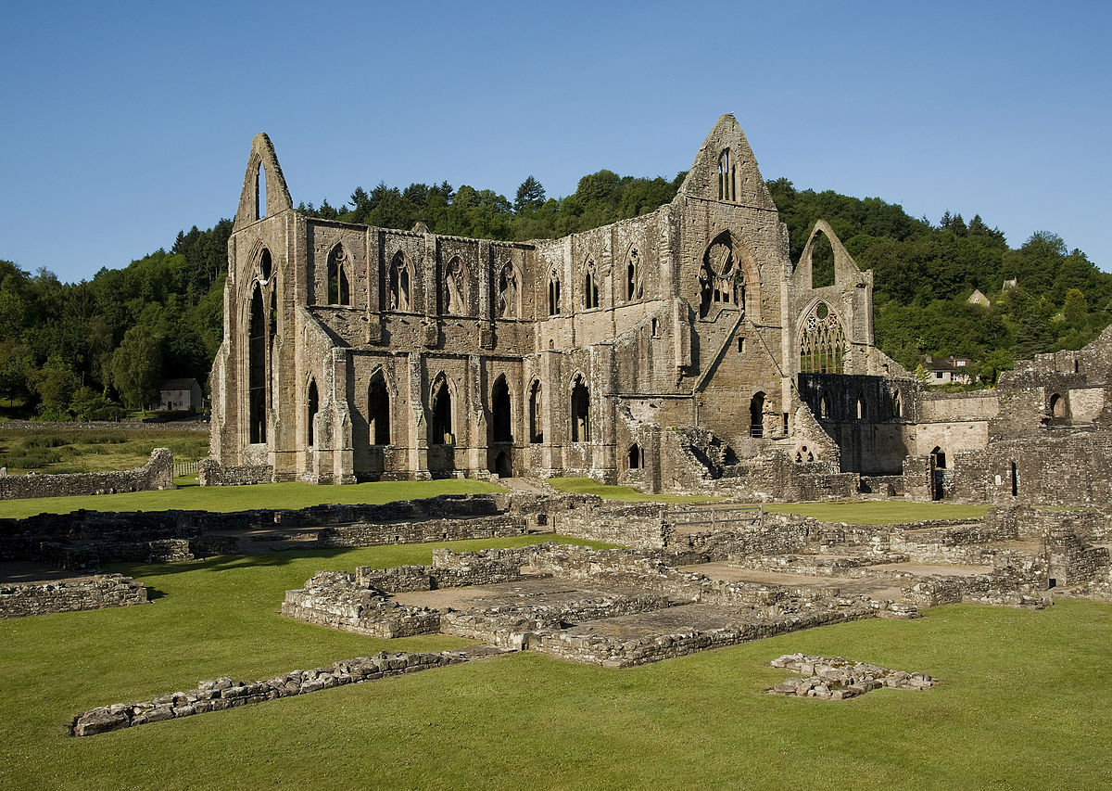
- I want you to imagine that you are writing to a medieval Abbot because you want to find out about life as a monk in the Middle Ages. Complete the following letter:

Dear Father in Christ*

I am researching what it is like to live in a medieval monastery. I already know quite a lot about medieval monasteries. For example, ……………………………………………………………………………………………………………………………………………………………………………………………………………………………………………………
……………………………………………………………………………………………………………………………………………………………………………………………………………………………………………………
……………………………………………………………………………………………………………………………………………………………………………………………………………………………………………………
……………………………………………………………………………………………………………………………………………………………………………………………………………………………………………………
……………………………………………………………………………………………………………………………………………………………………………………………………………………………………………………
……………………………………………………………………………………………………………………………………………………………………………………………………………………………………………………
……………………………………………………………………………………………………………………………………………………………………………………………………………………………………………………
……………………………………………………………………………………………………………………………………………………………………………………………………………………………………………………
…………………………………………………………………………………………………………………………

*this is the formal way of addressing an Abbot

But I still need to ask you some questions.
Firstly, …………………………………………………………………………………………………………
…………………………………………………………………………………………………………………………
Secondly, ………………………………………………………………………………………………………
…………………………………………………………………………………………………………………………
Thirdly, …………………………………………………………………………………………………………
…………………………………………………………………………………………………………………………
Fourthly, …………………………………………………………………………………………………………
…………………………………………………………………………………………………………………………
Fifthly, …………………………………………………………………………………………………………
…………………………………………………………………………………………………………………………
Sixthly, …………………………………………………………………………………………………………
…………………………………………………………………………………………………………………………
Finally, …………………………………………………………………………………………………………
…………………………………………………………………………………………………………………………
Many thanks for your kind assistance.
Yours sincerely

…………………………………………………

