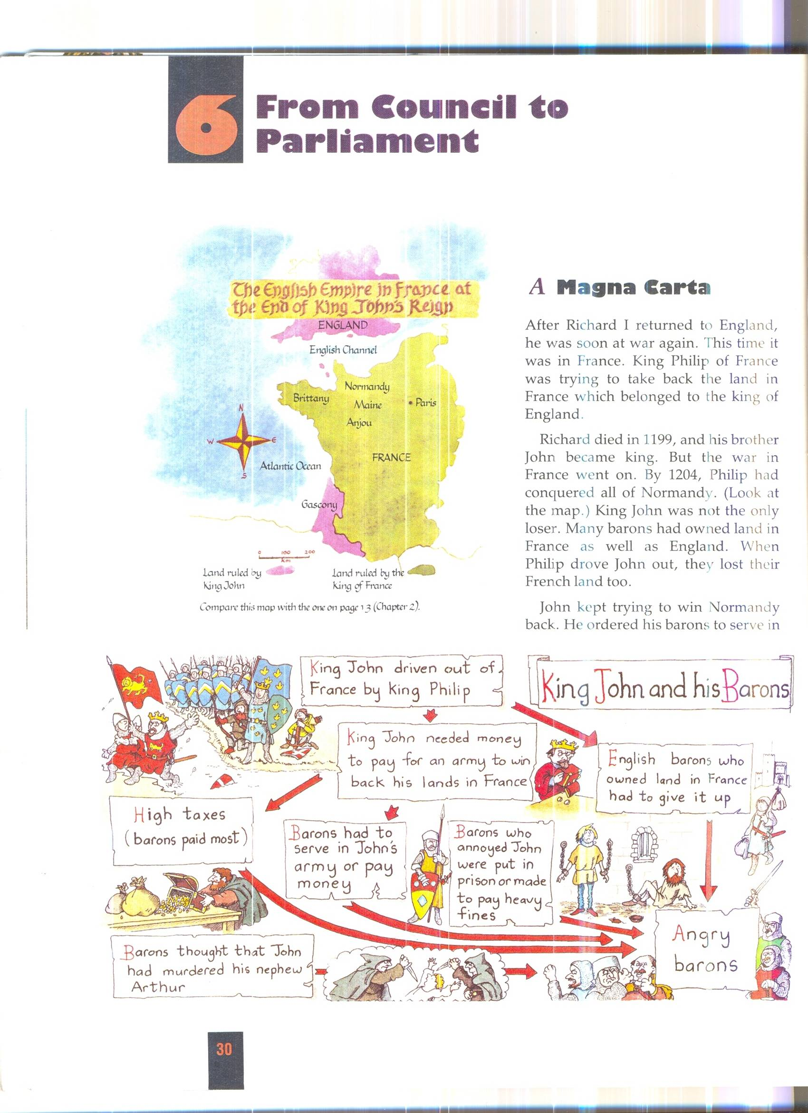

Questions

1. Explain the different reasons why the Barons were angry with King John.

2. Which two promises in the Magna Carta would most please the Barons?

3. Which three promises in the Magna Carta made sure that free men were treated properly by the courts?

4. The Magna Carta only gave rights to “free” people. Who was not free in Medieval England?

5. Other than the barons who else do you think was angry at King John?

6. Why do you think King John agreed to sign the Magna Carta?

Source 1. Some of the promises made by King John in the Magna Carta.



- Before I make the people pay taxes, I will
ask the advice of the lords in my council.

- No free man may be arrested or put in
prison unless other free men decide that
he is guilty, and unless he has a proper
trial.

- Judges will not be allowed to take bribes.

- People found guilty in court will not have
to pay bigger fines than they can afford.

- Barons will be fined only if the other
barons say they are guilty.

- The king must not interfere with the Church.

