
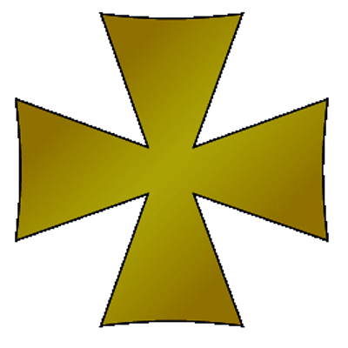
Year 7 History Magna Carta IST

Name: Form: 7S

IST project aim: To understand the importance of Magna Carta and to translate that into a modern day Magna Carta for KES Stratford

- To write a new Magna Carta that has clauses based on the original but is applicable to school life in 2017
- To show thought and skill in the presentation of your Magna Carta

 |  | A3 | A2 | A1
Specific Assessment Targets | Historical Accuracy | Your document shows some understanding of the original Magna Carta and some attempt to create a modern version. | You have written a clear and thoughtful document paying attention to the original and to ways in which it can be interpreted for school in 2017. | You have produced an outstanding document with a high level of historical accuracy and imaginative and thoughtful translations into school life in 2017.
Specific Assessment Targets | Skill | Some care and attention to detail is shown but overall the document lacks historical detail. | Care and attention to detail is demonstrated through a well presented document. | Great care and attention to detail is demonstrated. A high level of thought and craftsmanship has been shown.

You have demonstrated a good attempt to create a modern Magna Carta following the outline of the task. You have shown good care to detail in listing sensible demands to be put forward and in using language similar to the original Magna Carta, such as in your Preamble to your demands. This shows attention to historical accuracy. You also show some care in the presentation of the piece such as with your choice of font.

Year 7 History Magna Carta IST

Name: Form: 7S

IST project aim: To understand the importance of Magna Carta and to translate that into a modern day Magna Carta for KES Stratford

- To write a new Magna Carta that has clauses based on the original but is applicable to school life in 2017
- To show thought and skill in the presentation of your Magna Carta

 |  | A3 | A2 | A1
Specific Assessment Targets | Historical Accuracy | Your document shows some understanding of the original Magna Carta and some attempt to create a modern version. | You have written a clear and thoughtful document paying attention to the original and to ways in which it can be interpreted for school in 2017. | You have produced an outstanding document with a high level of historical accuracy and imaginative and thoughtful translations into school life in 2017.
Specific Assessment Targets | Skill | Some care and attention to detail is shown but overall the document lacks historical detail. | Care and attention to detail is demonstrated through a well presented document. | Great care and attention to detail is demonstrated. A high level of thought and craftsmanship has been shown.

You have displayed a simple attempt at designing a modern Magna Carta. You have included sensible demands to be made of the ‘king’ and have followed the outline of the task but could have perhaps expanded on the points being made. I would like to have seen some more imaginative content and a number of fully explained demands instead of a few simply explained ones. You have shown some care to detail by colouring it and having barons sign, but I would like to have seen a little more reflection on the original Magna Carta, the pages wouldn’t have been burned and damaged to the extent your document suggests, look to the original to see that it was actually copied on whole parchment.

