
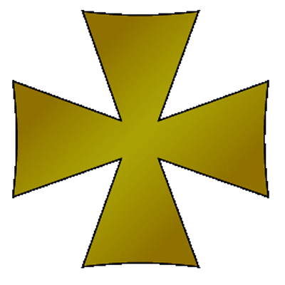
Year 7 History Magna Carta IST

Name: Form: 7K

IST project aim: To understand the importance of Magna Carta and to translate that into a modern day Magna Carta for KES Stratford

- To write a new Magna Carta that has clauses based on the original but is applicable to school life in 2017
- To show thought and skill in the presentation of your Magna Carta

 |  | A3 | A2- | A1
Specific Assessment Targets | Historical Accuracy | Your document shows some understanding of the original Magna Carta and some attempt to create a modern version. | You have written a clear and thoughtful document paying attention to the original and to ways in which it can be interpreted for school in 2017. | You have produced an outstanding document with a high level of historical accuracy and imaginative and thoughtful translations into school life in 2017.
Specific Assessment Targets | Skill | Some care and attention to detail is shown but overall the document lacks historical detail. | Care and attention to detail is demonstrated through a well presented document. | Great care and attention to detail is demonstrated. A high level of thought and craftsmanship has been shown.

You have demonstrated a good attempt to create a modern Magna Carta following the outline of the task. You have shown some care to detail in listing sensible demands to be put forward and in using language similar to the original Magna Carta. You have also shown some care in crafting the document, such as including signatures and a seal. However, the document could have been improved by including a Preamble (introduction at the beginning of the document) to the demands you wanted to make as was contained in the original Magna Carta. This would have explained the purpose of the document more fully.

Year 7 History Magna Carta IST

Name: Form: 7K

IST project aim: To understand the importance of Magna Carta and to translate that into a modern day Magna Carta for KES Stratford

- To write a new Magna Carta that has clauses based on the original but is applicable to school life in 2017
- To show thought and skill in the presentation of your Magna Carta

 |  | A3 | A2 | A1
Specific Assessment Targets | Historical Accuracy | Your document shows some understanding of the original Magna Carta and some attempt to create a modern version. | You have written a clear and thoughtful document paying attention to the original and to ways in which it can be interpreted for school in 2017. | You have produced an outstanding document with a high level of historical accuracy and imaginative and thoughtful translations into school life in 2017.
Specific Assessment Targets | Skill | Some care and attention to detail is shown but overall the document lacks historical detail. | Care and attention to detail is demonstrated through a well presented document. | Great care and attention to detail is demonstrated. A high level of thought and craftsmanship has been shown.

You have demonstrated a good attempt to create a modern Magna Carta following the outline of the task. You have shown some care to detail in listing sensible demands to be put forward. You have also shown some care in crafting the document, such as including a seal and I like the way you wrote ‘Magna Carta.’ However, the document could have been improved by including a Preamble (introduction at the beginning of the document) to the demands you wanted to make as was contained in the original Magna Carta. This would have explained the purpose of the document more fully. To achieve a higher mark you should have expanded on your demands and explained them more fully, rather than just listing them.

Year 7 History Magna Carta IST

Name: Form: 7K

IST project aim: To understand the importance of Magna Carta and to translate that into a modern day Magna Carta for KES Stratford

- To write a new Magna Carta that has clauses based on the original but is applicable to school life in 2017
- To show thought and skill in the presentation of your Magna Carta

 |  | A3 | A2 | A1
Specific Assessment Targets | Historical Accuracy | Your document shows some understanding of the original Magna Carta and some attempt to create a modern version. | You have written a clear and thoughtful document paying attention to the original and to ways in which it can be interpreted for school in 2017. | You have produced an outstanding document with a high level of historical accuracy and imaginative and thoughtful translations into school life in 2017.
Specific Assessment Targets | Skill | Some care and attention to detail is shown but overall the document lacks historical detail. | Care and attention to detail is demonstrated through a well presented document. | Great care and attention to detail is demonstrated. A high level of thought and craftsmanship has been shown.

You have created a very good modern version of the Magna Carta following the outline of the task. You have shown good care to detail in listing sensible and thoughtful demands to be put forward. You have also shown care in crafting the document, such as including the seal and the choice of font. The Preamble to the demands is particularly good; it shows you have paid attention to historical accuracy as the original Magna Carta contained a Preamble. One thing to note though – Magna Carta was not a letter to the King; writing ‘Yours faithfully’ at the end suggested the format of a letter, which would not be historically accurate.

