Was the Black Death a disaster?

Ring-a-ring o' rosies,
A pocket full of Posies,
"A-tishoo, A-tishoo!"
We all fall down!
Represents the black sores that the Plague gave!
Symbolises the flowers that people carried around to hide the smell of death!
This was originally 'Ashes, Ashes' meaning the ashes of all the dead bodies flying around!
Represents everyone dying!
Symptoms of the Black Death
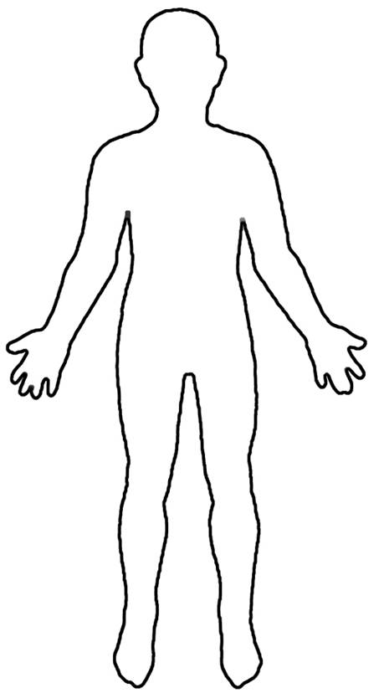

I CAUSED THE PLAGUE! I am a flea from a rat.
It wasn’t my fault, I didn’t realise that sucking the black rat’s blood and then a human would spread the Plague. I'm not a bad flea really! :(

I’m not a bad flea really L

What caused the Plague?
Plague - an epidemic disease that causes high mortality
Mortality -death
Symptoms - evidence of a disease
Buboes - swellings

