Causes of the Peasants’ Revolt

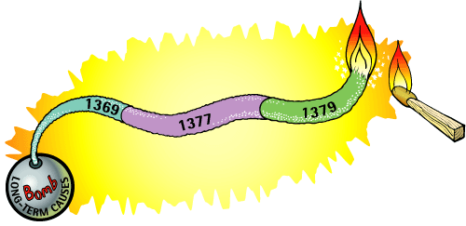

- Copy the drawing above. Below the bomb write a list of the long-term causes of the Peasants’ Revolt. These are things that had been going on for a long time before 1381. They are causes but they might not have led to revolt on their own.
- Write out headings of the causes. Do not use full sentences. For example, instead of writing: ‘The war had cost a lot and was still costing a lot of money’, write ‘expensive war’.
- Along the fuse write the short-term causes. These are things that happened very close to 1381 and made the peasants angry.
- But the fuse still needs a match to light it! Write near the match the event that made the peasants’ anger explode in 1381.

