Why was the Black Death so frightening? Your turn to decide!
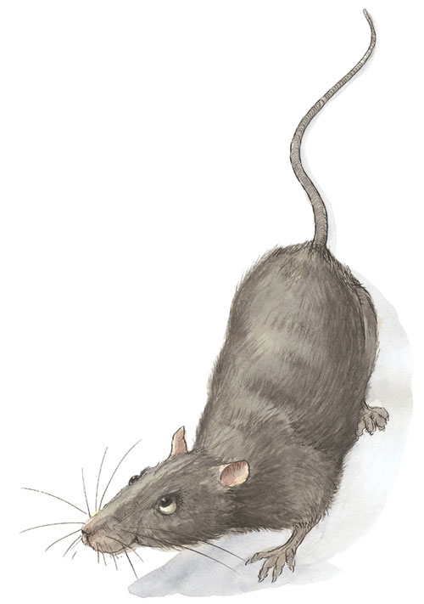
Below are statements about the Black Death. Read all the statements. As you read, think about whether the statement is a cause of the Black Death, a description of the Black Death (symptoms, how people reacted and so on), or a result of the Black Death.
- Sort out all the statements into cause, description or result.
- People prayed and went on pilgrimages to stop themselves catching the plague.
- The plague came into England on ships from the continent.
- Most people died very quickly, within three or four days.
- Symptoms of plague were big lumps under armpits and in the groin, black and blue blotches, vomiting blood.
- The plague was carried by fleas on the black rat.
- In the 14th century, people did not know how to stop the plague from spreading.
- The plague was worse in the towns where people lived closer to each other.
- The number of people in Britain (population) decreased because of the plague. Probably about one-third of the people died.
- The plague came back in 1356, 1361, 1368 and 1375. It carried on coming back until the Great Fire of London in 1666.
- The 1361 plague was called the ‘Pestilence of Children’ because children were more likely to die from it than adults.
- Some people blamed the Jews for the plague.
- Some people thought God had sent the plague.
- Some people whipped themselves to try to stop the plague spreading.
- Some cities banned visitors from coming in, but the plague still spread.
- Whole villages were abandoned because of the plague.
- The Black Death was a very important turning point in the history of the Middle Ages. This is because it changed life very dramatically.
2. Now write out three paragraphs that answer the question: Why was the Black Death so frightening? Organize your paragraphs into causes, description and results.

