Life in medieval times
You are the researcher for a Hollywood film company. It wants to make a film set in the Middle Ages. Your job is to research the historical background for the film.
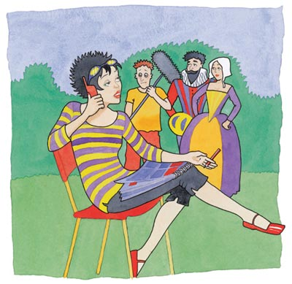
You receive the following instructions from the director:
Dear Researcher
How are things in jolly little England? We do envy your history. All those quaint old villages. Just the right setting for our next film. Now, apparently I missed getting that Oscar last year because I was careless over historical detail. Hah! I don’t want that happening again, so I’m relying on you to help me out. Between you and me, I'm very confused. I’ve looked at a few pictures and either the peasants are having a jolly good time dancing around maypoles and getting drunk or they’re dressed in rags and being pushed around like slaves. Now tell me – which version do I believe? HELP!
Don’t let me down now. I need:
Scene 1 | Scene 2
Set in a medieval village.  What would the peasants be doing?  What would their houses look like?  What other buildings would be there?  What clothes would they be wearing?  What would the landscape around be like?  What would be going on in the fields? | Set in a medieval town.  What would the people be doing?  What would their houses look like?  What other buildings would be there?  What clothes would they be wearing?

For both the scenes I need advice about sound effects. By the way, I don’t mind which part of England the film is set in – you decide!
Looking forward to hearing from you.

Susannah Vincente
- Use all the information you can find to give background information for the two scenes. You will need to make some choices. For example: What time of year is it in the village? Is it time for ploughing/sowing/harvesting? In the town, is it a fair day or a market day or neither?
You might want to provide plans/drawings/maps to help explain your ideas.
- Write a letter to go with your background information. In the letter you should make sure you answer her question:
‘I’ve looked at a few pictures and either the peasants are having a jolly good time dancing around maypoles and getting drunk or they’re dressed in rags and being pushed around like slaves. Now tell me – which version do I believe?’

