A medieval village
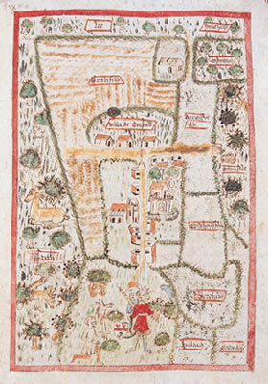
- Look at the picture above of the village of Boarstall. Make a sketch of the village. Label the following on your sketch: church, peasant houses, mill, field (with strips), woodland, demesne, manor.
- Put boxes around your plan of a medieval village and fill in brief and important information about the village. For example, draw an arrow from a box to the mill. Inside you could write ‘The mill was used to grind corn to make flour for bread.’ Make sure the boxes are big enough for what you want to write, or do the writing first and then draw the box.
- Read the paragraph below about medieval life. Each sentence uses one of the following sources of information: Domesday Book, archaeology, poetry, Manor Court records. Match each sentence to the source of information the historian has used.
In the village of Gelly there was enough land for six ploughs. The peasants who are villeins had to do three days work each week ploughing, weeding and harvesting. They were so poor that they could hardly feed their children. Only two buildings in the village were made of stone.

