How did the Black Death make life better for peasants?

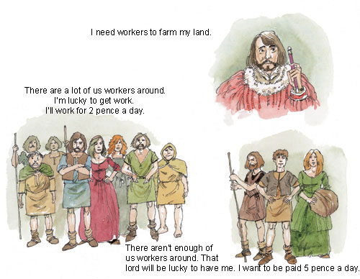
1. Look at the cartoon picture above.
(a) Is the large group showing peasants before or after 1349?
(b) Is the small group showing peasants before or after 1349?
(c) Which group will be paid the higher wages?
(d) Why?
2. Below is a sequence of statements that explain how the Black Death made life better. The first and last statements are in order but the others need to be put in the correct order. Sort them out into an order that answers the question: ‘How did the Black Death make life better for peasants?’
1 The Black Death killed about one-third of the population of England.
Fewer people meant there were fewer peasants to work the land.
This meant there were fewer people buying food.
So, the lords had to pay more to get workers.
Fewer people buying food meant food was cheaper.
Peasants had more money to spend because wages were higher and food was cheaper.
7 The Black Death made life better for peasants because they became richer and more powerful.
3. The Black Death made life harder for many lords. Why do you think this happened?

