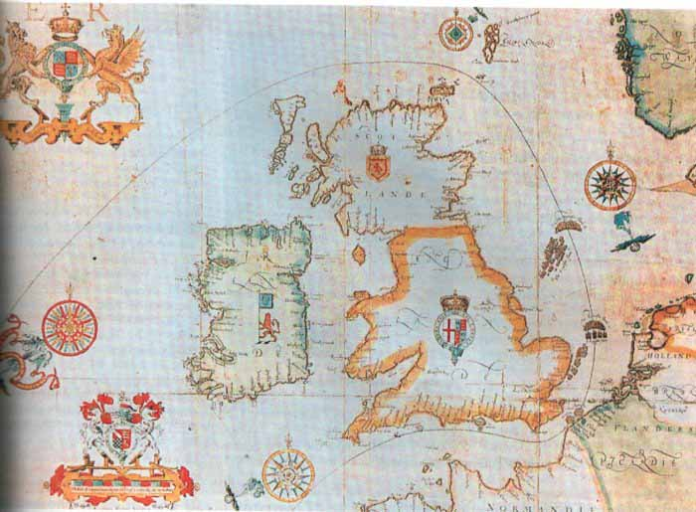

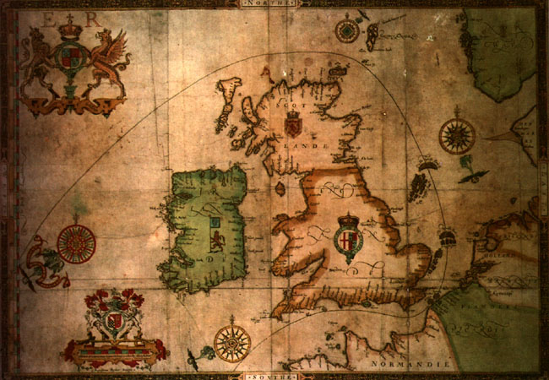

ORIGINAL MAPS SHOWING THE ROUTE TAKEN BY THE SPANISH ARMADA.

