The Spanish Armada
The Spanish Armada of 1588 was an attempt by Phillip of Spain to conquer England. Phillip, who had been married to Queen Mary, was angry that her sister, Queen Elizabeth had refused his proposal of marriage. He was also very angry that England had returned to Protestantism. His anger bubbled out of control as Elizabeth did nothing to stop English sailors plundering the Spanish ships returning from the Americas.
Phillip planned an invasion of England. He would send his Spanish Armada of 131 ships and 17,000 men to France. Here his armada would collect a further 16,000 Spanish soldiers who had been fighting in Holland. The fleet was then to cross the English Channel and defeat the armies of Queen Elizabeth's England.
The Spanish Armada set off after much preparation and reached the initial destination of Calais in early August of 1588. The English though had seen the Armada coming. Six boats were filled with firewood and set alight. They drifted towards the anchored Spanish Fleet. Upon seeing them the Spaniards panicked and set sail into the English Channel. Here they were met by the English Fleet. The Spanish Admirals knew that they had enough men to overpower the English boats and tried to get close enough to board and attack the English ships. Their plan failed though. The English boats were too fast and could keep well away from the Spaniards. More significant was the type of boat that the English Fleet had. Each boat was armed with cannon. These were brought to bear upon the Spanish Fleet with disastrous consequences: the Spaniards were easy targets.
Fearing the destruction of their fleet at the hands of the English guns the fleet set sail into the North sea. They could regroup later and attack elsewhere. The weather though worsened and many of the surviving boats were swept against the rocks of the Scottish and Irish coasts. Less than 10,000 of Phillips men returned home. The Armada had been defeated by a combination of excellent tactics and atrocious weather.
As a result of the Armada England was a much more powerful nation. Elizabeth could be reasonably secure in the knowledge that another invasion was not likely, certainly within the next few years. The Spanish had less ships with which they could protect their trading ships and so English sailors could plunder with greater ease. The failure of the Armada made England a much more powerful nation.
- You need to: Summarise the account of the Spanish Armada in bullet points. Write about 10 bullet points so that you have a detailed account of what happened. You may be examined on this in future...
- Draw an illustration if you get the chance.

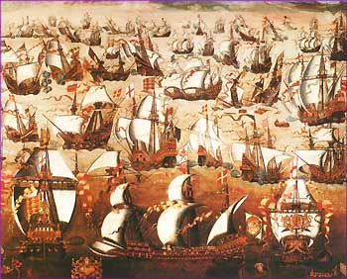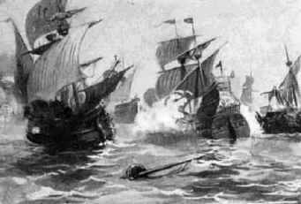
Spanish Armada Quick Quiz Teacher’s copy
True or False? Put your book away and try and answer these questions.
- The Spanish Armada of 1588 was an attempt by Phillip of Spain to conquer England. (T)
- Philip planned to send 131 ships and 17,000 men to France. (T)
- The Spanish Armada set off in 1922 (F)
- Only 15 men returned home (F)
- The Armada was defeated because of appalling weather and because they ran out of food (F)
- The failure of the Armada made England a lot less powerful nation (F)
- Philip of Spain had been married to Queen Harriet (F)
- The Spanish Armada occurred under the reign of Elizabeth 1 (T)
- The English could plunder the trading ships of the Spanish with ease (T)
- The Spanish Admiral’s plan to overpower the English boats failed (T)

Spanish Armada Quick Quiz
True or False? Close your book and try and answer these questions.
- The Spanish Armada of 1588 was an attempt by Phillip of Spain to conquer England. T/F
- Philip planned to send 131 ships and 17,000 men to France. T/F
- The Spanish Armada set off in 1922. T/F
- Only 15 men returned home T/F
- The Armada was defeated because of appalling weather and because they ran out of food T/F
- The failure of the Armada made England a lot less powerful nation T/F
- Philip of Spain had been married to Queen Harriet T/F
- The Spanish Armada occurred under the reign of Elizabeth 1 T/F
- The English could plunder the trading ships of the Spanish with ease T/F
- The Spanish Admiral’s plan to overpower the English boats failed T/F

Spanish Armada Quick Quiz
True or False? Close your book and try and answer these questions.
- The Spanish Armada of 1588 was an attempt by Phillip of Spain to conquer England. T/F
- Philip planned to send 131 ships and 17,000 men to France. T/F
- The Spanish Armada set off in 1922. T/F
- Only 15 men returned home T/F
- The Armada was defeated because of appalling weather and because they ran out of food T/F
- The failure of the Armada made England a lot less powerful nation T/F
- Philip of Spain had been married to Queen Harriet T/F
- The Spanish Armada occurred under the reign of Elizabeth 1 T/F
- The English could plunder the trading ships of the Spanish with ease T/F
- The Spanish Admiral’s plan to overpower the English boats failed T/F

