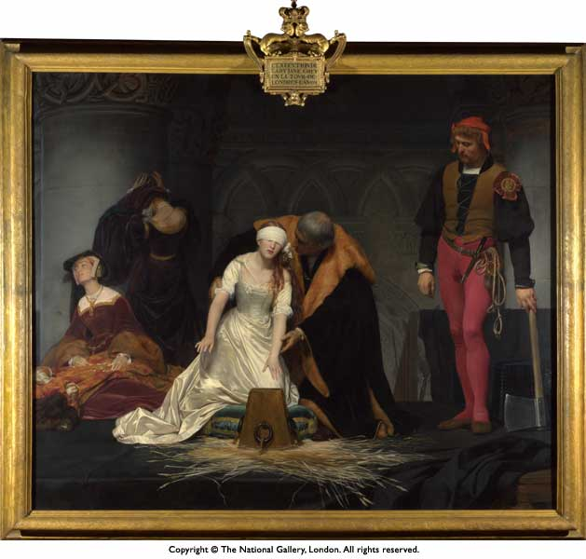

Name something you can see

How does this picture make you feel?

What tricks has the artist used to make you feel like that?

