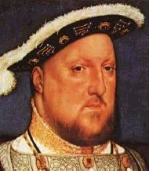
Henry VIII – A Picture Study
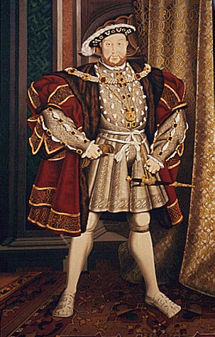

Questions about these pictures
Answer the questions by left-clicking at the end of each question. A flashing line will appear (the cursor) and you can then start to type your answer. You might want to use a different font and colour for your answers. When you have answered all the questions save your work, giving it a new name and print it.
- Look carefully at the clothes this person is wearing. Describe them. What do they tell us about how wealthy he is?
- What other things in the pictures indicate how wealthy and powerful he is? Describe them and explain what they tell us about Henry, and why.
- Look at his face. Look carefully at his eyes, his mouth. Describe his features. What kind of personality do you think this man has? What makes you think this?
- What do you think the artist (and Henry VIII) wanted people to think when they saw these portraits? How successfully do you think the artist has done this? What makes you think this?
- Do you think this is really what Henry looked like? Why/why not? How can we be sure?
- Imagine you could travel back in time and meet the person in this portrait. What would you want to ask him? Write down three questions about this person that you would like to know the answers to.

