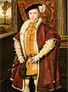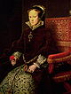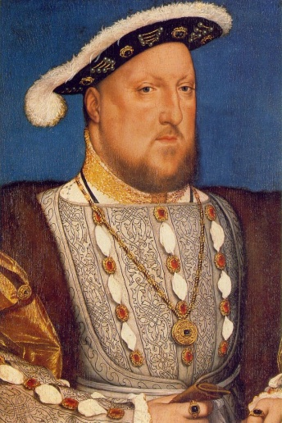
Henry VII

1558-1603

Name of King or Queen
Dates they ruled from.

