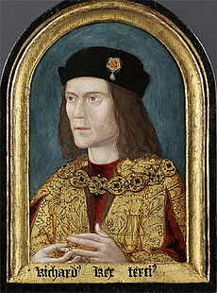
Where is the body?

5. Your Overall Decision: Where is the body? Why do you believe that?
2. What was our victim’s history?

3. What was our victim like?
4. Important Evidence:
What happened in battle?

How did he die? Interpretations?

6. What happened to his body immediately after his death?

7. Do you think anyone should have been found guilty for our victim’s death?

Your names:

Detective/Inspector/Sergeant……………………………………

…………………………………………………………………………………..
1.Who is our victim?

