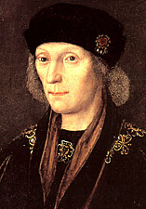
The Battle of Bosworth
Born: 28 January 1457 : Pembroke Castle, Wales
Accession: 22 August 1485 : Battle of Bosworth Field
Coronation: 30 October 1485 : Westminster Abbey
Died: 21 April 1509 : Richmond Palace
Buried: 11 May 1509 : Westminster Abbey

The Battle of Bosworth was fought on August 22nd 1485. Henry Tudor had marched with his force from Milford Haven in Wales where he had landed with about 2000 men. The Battle of Bosworth is one of England’s defining battles as it ended the reign of Richard III and led to Henry Tudor becoming Henry VII, the first of the Tudor monarchs, a dynasty that lasted to 1603 and included the reign of two of England’s most famous monarchs – Henry VIII and his daughter Elizabeth I.

To launch his campaign against Richard III, Henry needed money. This he got from Charles VIII of France who hoped that a conflict in England would suitably distract any attention away from his wish to take Brittany. Henry sailed from Harfleur on August 1st with a force of between 400 and 500 loyal followers and about 1500 French soldiers. The force landed at Milford Haven on August 7th and marched north along the Cardigan coastline before turning inland towards the Cambrian Mountains and then the River Severn which he followed to the English border.

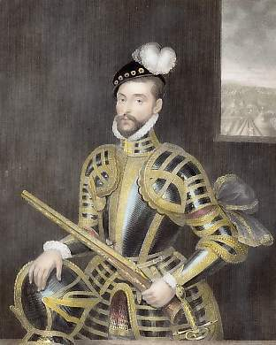
By August 12th, Henry had won the support of the most influential landowner in South Wales – Rhys ap Thomas – who had been promised the Lieutenancy of Wales if Henry won. However, regardless of his support in Wales, Henry needed more support in England. He turned to his step-father Lord Stanley and his brother Sir William Stanley. They owned large areas of land in north Wales and in the Border region. Both men secretly gave money to Henry – Lord Stanley’s eldest son was being held prisoner by Richard III as an insurance of good behaviour. The uncle of the Earl of Shrewsbury, Gilbert Thomas, also gave his support to Henry along with 500 men.

Richard III was at Nottingham Castle when he learned about Henry’s invasion. He did nothing as he assumed that the major landowners of Wales would see Henry as a threat and group their forces together and attack him. When he realised that he had made a mistake, Richard marched his forces to Leicester. The two armies fought two-and-a-half miles south of Market Bosworth.

Henry had a force of about 5000 men while Richard’s army probably was nearer 12,000. However, 4,000 of these soldiers belonged to the Stanley family and no one was sure if the Stanley’s could be trusted. It is thought that Richard did not trust Lord Stanley as he had a reputation of fighting for whoever he felt was going to be the most generous in victory. For Richard it was to be a shrewd judgement of character – and one that led to his death.


The fighting began early in the morning of August 22nd. The two Stanley armies stayed away from the actual fighting at this stage so that the contest was literally a battle between Richard’s and Henry’s forces. Richard held the crest of Ambien Hill with Henry at the bottom in more marshy land. When Henry’s men charged up the hill, they sustained heavy casualties. However, Henry had recruited long bow men while in Wales and these inflicted equally severe wounds on the forces of Richard as being at the top of a hill did not protect them from a deluge of long bow arrows.

Though there are no contemporary accounts of the battle, it is generally accepted that it lasted about two to three hours. Casualties on both sides were heavy.

What turned the battle seems to have been a decision made by Richard III to target Henry himself. Henry was seen making a move to where Lord Stanley was almost certainly with the intent to urge Stanley to use his forces on Henry’s side. With some trusted men Richard charged at Henry. He nearly succeeded in getting to Henry, and Tudor’s standard bearer, William Brandon, who was very near his leader, was killed. However, Henry’s bodyguards closed ranks and the future king was saved.

For the duration of the battle, the forces of the Stanley family had stood by the sides – therefore fulfilling what Richard believed - but at this critical moment the army of Sir William Stanley attacked Richard, seemingly coming to the aid of Henry. Richard was killed and his forces broke up and fled.

Lord Stanley picked up the slain Richard’s crown and placed it on Henry’s head. Richard’s naked body was put over a mule and taken to Leicester to be buried.
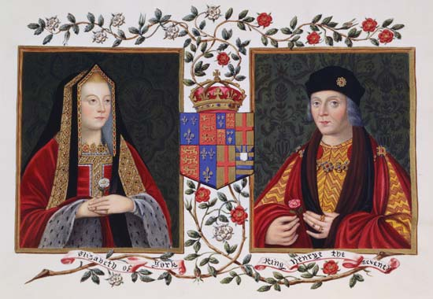

The defeat of Richard ended the reign of the Plantagenet’s and introduced the reign of the Tudors. By marrying Elizabeth of York, Henry unified both houses of Lancaster and York.

