Henry Tudor’s problems
Here are some of the problems facing the new King Henry Tudor.
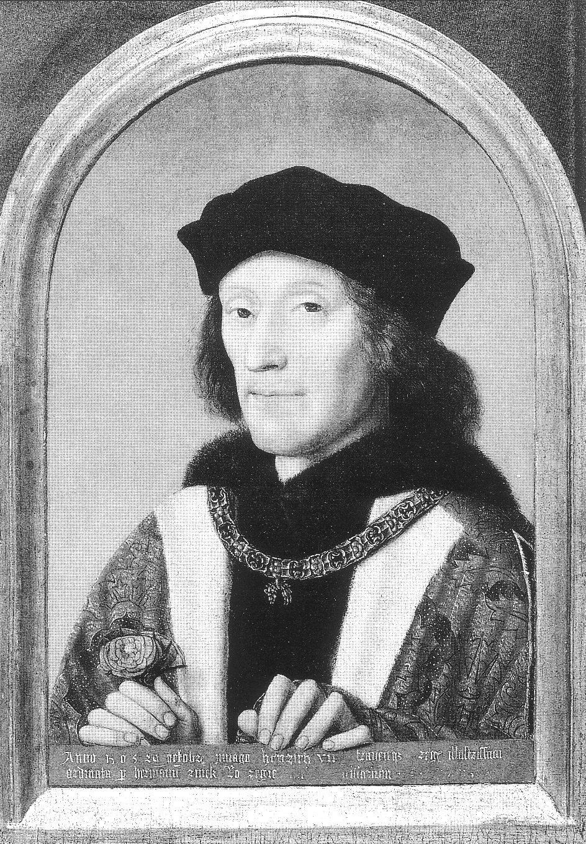
How to stop the
Wars of the
Roses?

How to develop culture and traditions?

How to protect the kingdom from possible enemies?

How to deal with the leaders of other kingdoms?

How to make the kingdom richer?
How to keep the nobles under control so they don’t threaten the Tudor dynasty?

Here are some of the solutions Henry used to deal with the above:
He took care of the crown’s money, and checked the accounts every day.
He taxed and fined them a lot of money for having their private armies.
He married Princess Elizabeth from the House of York.

He gave money to build a royal library

He welcomed support from the Pope.
His eldest son Arthur married the Spanish Princess Katherine of Aragon.

He became the first king in almost 100 years to pass his crown to his son.
His daughter Princess Margaret was married to King James IV of Scotland.
He didn’t give them any important jobs in his government.

He gave money to the new collages in Oxford and Cambridge.
He gave money and support to the explorer John Cabot to explore the Atlantic.

He made people pay more tax.

He executed Perkin Warbeck in 1499 for leading a rebellion against him.
He defeated the Yorkists at the Battle of Stoke in 1487.
He kept the Welsh happy by passing new laws or ‘charters of freedom’.

He encouraged Renaissance styles to be introduced in the kingdom’s art.
He traded woollen cloth with Europe because he knew people wanted to buy it!
Lambert Simnel was put in the royal kitchens for pretending to be one of the Princes in the Tower!

Which was his greatest achievement? Explain your answer fully.

