The gunpowder plot: A Conspiracy or Not?

'Remember, remember, the fifth of November. Gunpowder, treason and plot.'

Or was it?
- Read the two different versions of the Gunpowder Plot and decide for yourself...
The Facts
A small group of Catholics, (including Guy Fawkes) decided to blow up the King on the State opening of Parliament. They hoped that this would lead to a Catholic King coming to the throne. Fawkes was an explosives expert who had served with the Spanish army in the Netherlands.
The group rented a cellar beneath the Houses of Parliament and stored 20 barrels of gunpowder, supplied by Fawkes. The date for the deed was set for November 5th. They recruited others sympathetic to their cause including Francis Tresham whose brother-in-law, Lord Monteagle, was a member of Parliament. Concerned for his brother-in-law's safety, Tresham sent him a letter advising him not to attend Parliament on November 5th. Monteagle alerted the authorities and a search of the Houses of Parliament led to the discovery of Guido Fawkes standing guard over the barrels of gunpowder. He was tortured and revealed the names of the conspirators. Catesby and Percy and two others were killed resisting arrest. The others were tried for treason and executed.
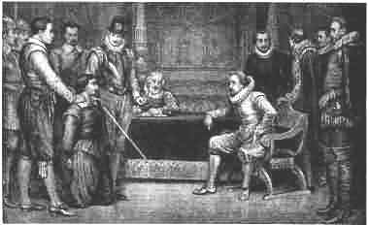

The Protestant View - The Conspirators were Guilty

This picture shows the conspirators hatching the plot to blow up the King and parliament. They are grouped close together which shows that they are hatching a secret plot. Robert Catesby, Guido (Guy) Fawkes, Thomas Winter, John Wright and Thomas Percy were known to be Catholics. Guido Fawkes was an explosives expert. He had only recently returned to England maybe specifically to set the explosives. Francis Tresham was only thinking of his brother-in-law's safety when he sent the letter. Gunpowder was not normally kept in the cellars under the Houses of Parliament. It was obviously put there by the conspirators. Guido Fawkes revealed the names of the conspirators.

The Catholic View - The Conspirators were framed by the Protestants
Many historians today agree with the Catholics of the time that the Gunpowder Plot conspirators were framed by James I's chief minister, Robert Cecil.
Cecil hated the Catholics and wanted to show them to be against the country. It is believed that Francis Tresham, who sent the warning note to his brother-in-law, may have been working for Cecil. There is evidence to support this view:
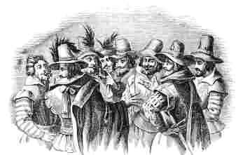
This picture showing the conspirators, was made by a Dutchman who had never seen the conspirators. Cecil is quoted as saying '..we cannot hope to have good government while large numbers of people (Catholics) go around obeying foreign rulers (The Pope).' This shows how much he hated the Catholics and wanted rid of them.
Lord Monteagle received the warning letter at night. The night he received it was the only night in 1605 that he stayed at home. Could he have been waiting for it?
  - All available supplies of gunpowder were kept in the Tower of London.
  - The cellar was rented to the conspirators by a close friend of Robert Cecil.
  - All of the conspirators were executed except one - Francis Tresham.
  - The signature on Guy Fawkes' confession did not match his normal signature.
- You need to: Answer this question in full sentences: Were the Catholics framed? (Were the gunpowder plotters ‘set up’ to show that they were wicked people who hated their King?)
- Give at least 5 reasons why, using the text above.
- Then, do the gunpowder plot crossword.

