The Gunpowder Plot – A Setup or Not?

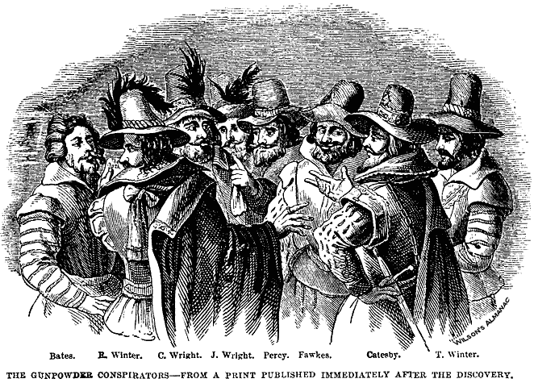

The first problem that James had to solve was religion. The Catholics hoped he would support them. So did the Puritans. They belonged to the Church of England, but wanted to change it. They wanted simple services and plain churches.
James listened to their views when a meeting of church leaders took place at Hampton Court Palace in 1604. In the end, he rejected the Puritans’ demands. He soon made the Catholics angry, too, when he ordered Roman Catholic priests to leave the country.
A small group of Catholics were so angry that they decided to do something about it. They planned to kill James when he came to the Houses of Parliament. They would use gunpowder to blow him up. Then, they would seize his daughter Elizabeth and make sure she was brought up as a Catholic.
When the plot was discovered, the government gave the following account of it. As you read it, look at the notes on the right, because some historians do not think that the government told the whole truth about it.

Now turn the sheet over and read the story on the left and the notes on the right.

It was Robert Catesby who thought up the idea. Thomas Percy rented a house next to the House of Lords. (Your teacher can show you this if you ask.)  The plotters started to tunnel through into the House of Lords, but the foundations were nearly three metres thick.  Then, they found that a coal cellar running under the House of Lords was to be let. In spring 1605, Percy rented it. The plotters brought in 36 barrels of gunpowder and hid them under wood and coal.  A soldier called Guy Fawkes was to stay in London and light the fuse on November 5th. Most members of the gang were to go to country houses to wait for the plot to succeed.  But, on October 26th, a man called Lord Monteagle was just about to have dinner when his servant brought him a letter. The servant said that a tall stranger had given it to him in the street. The servant read out the note. It contained a grim warning. (Ask your teacher for a copy of the note)  Monteagle did not wait for his dinner. He went straight to London to see the King’s minister, Robert Cecil. Cecil later reported it to the King.  On the night of November 4th, guards searched the cellar and found a tall, brown-haired man. He said that he was John Johnson, a servant of Percy. He was arrested at once. In his pocket were three matches and a tinder-box. He also had a watch.  John Johnson was taken to the Tower of London and tortured. He admitted that he was really Guy Fawkes. On November 9th, he made a confession about his part of the in the plot. (Ask your teacher to see a copy of the confession).  Meanwhile, other plotters were traced to Holbeech House in the Midlands (stopping at Dunchurch on the way!). On November 8th they were surrounded by hundreds of sheriff’s men. There were only thirteen plotters and they had few weapons.  Catesby and Percy were killed by the same bullet. Others died, too. The rest were taken to London and tried for treason.  Each was found guilty and all of them were hung, drawn and quartered in January 1606. Guy Fawkes was so weak he had to be helped on to the scaffold. | Nobody saw this tunnel. Nor did anyone explain what the plotters did with the stones and the earth while they were digging.  It was owned by a government official, who died suddenly on the morning of November 5th. No one is certain what he died of.  All gunpowder was kept in the Tower of London and controlled by the government. The records for 1604 are missing.  The King was not due to go to Parliament until November 5th, so why did Monteagle rush off at once with the letter?  Monteagle’s name does not appear in any of the plotters’ accounts. It was either rubbed out or pasted over.  The government arrested the plotters’ servants on November 5th.  Cecil was supposed to have said ‘Let me never see them alive’. Their killer was given a pension of 10p a day for life.  No witnesses were called. Cecil did not show anyone the original confessions. Tresham was not arrested until November 12th. He was taken to the Tower of London, where he died over a month later. No one knows how he died.
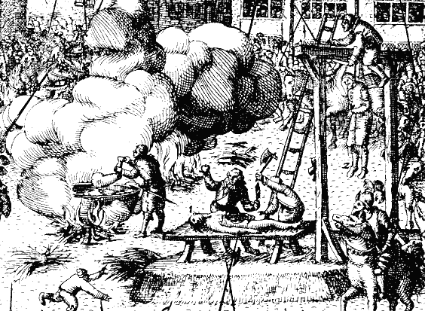

Your task now is to fill in the blanks on the Gunpowder Plot: the Official Version sheet.

