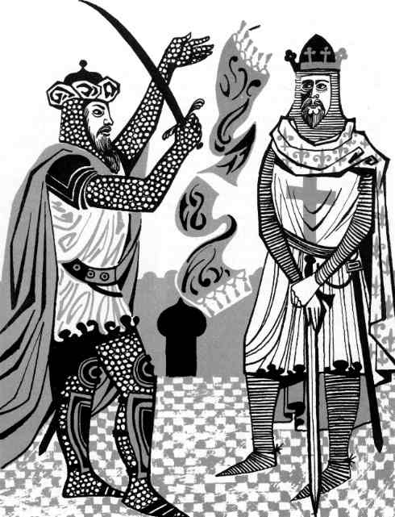
Saladin the Merciful & Richard the Lionheart
Saladin and Richard the Lionheart are two names that tend to dominate the Crusades. Both have gone down in Medieval history as great military leaders though their impact was limited to the Third Crusade.
Saladin was a great Muslim leader. The more successful Saladin was, the more he was seen by the Muslims as being their natural leader.
The Christians of western Europe were stunned by the success of Saladin. The pope, Gregory VIII, ordered another crusade immediately to regain the Holy City for the Christians. This was the start of the Third Crusade.
Richard captured Cyprus first before moving on to Acre. The port could not cope against such a force and in July 1191, it fell to the Christians. However, the siege had had its impact on Philip - he was exhausted and left for France. Richard was left by himself. While in control of Acre, the Christians massacred 2000 Muslim soldiers who they had captured. Saladin had agreed to pay a ransom for them but somehow there was a breakdown in the process of payment and Richard ordered their execution.
Richard was determined to get to Jerusalem and he was prepared to take on Saladin. The march south to Jerusalem was very difficult. The Crusaders kept as near to the coast as possible to allow ships to supply them. It was also slightly cooler with a coastal breeze. Regardless of this, the Christians suffered badly from the heat and lack of fresh water. At night when the Crusaders tried to rest, they were plagued by tarantulas. Their bites were poisonous and very painful.
Both sides fought at the Battle of Arsur in September 1191. Richard won but he delayed his attack on Jerusalem as he knew that his army needed to rest. He spent the winter of 1191 to 1192 in Jaffa where his army regained its strength. Richard marched on Jerusalem in June 1192.
However, by now even Richard the Lionheart was suffering. He had a fever and appealed to his enemy Saladin to send him fresh water and fresh fruit. Saladin did just this - sending frozen snow to the Crusaders to be used as water and fresh fruit. Why would Saladin do this?
There are two reasons. First, Saladin was a strict Muslim. One of the main beliefs of Islam is that Muslims should help those in need. Secondly, Saladin could send his men into Richard's camp with the supplies and spy on what he had in terms of soldiers, equipment etc.
What they found was that Richard only had 2,000 fit soldiers and 50 fit knights to use in battle. With such a small force, Richard could not hope to take Jerusalem even though he got near enough to see the Holy City. Richard organised a truce with Saladin - pilgrims from the west would once again be allowed to visit Jerusalem without being troubled by the Muslims. Neither Richard or Saladin particularly liked the truce but both sides were worn out and in October 1192, Richard sailed for western Europe never to return to the Holy Land.

However, for Richard the adventure was not over. On his journey back to England, his ship got wrecked in a storm. He found that he had to travel through Austria. This country was owned by a sworn enemy of Richard - Duke Leopold of Austria. Leopold had originally been a leading member of the Third Crusade but he had been ridiculed by Richard who did nothing to stop his men making fun out of Leopold. They called him "the sponge" because he drank so much and was drunk too often! Leopold had lost a lot of prestige and now he had a chance to avenge himself. Richard was betrayed to Leopold who held him captive for two years until a ransom was paid for him. Richard arrived home in 1194.
Richard was known as the "Lionheart" by his people. Even the Muslims praised him. The Muslim writer Baha wrote about Richard while the Third Crusade was going on:
"......a very powerful man of great courage........a king of wisdom, courage and energy.....brave and clever."

Medieval Sourcebook:
Itinerarium Peregrinorum et Gesta Regis Ricardi:
Richard the Lionheart Makes Peace with Saladin, 1192

After Acre…
As his illness became very grave, the King despaired of recovering his health. Because of this he was much afraid, both for the others as well as for himself. Among the many things which did not pass unnoted by his wise attention, he chose, as the least inconvenient course, to seek to make a truce rather than to desert the depopulated land altogether and to leave the business unfinished as all the others bad done who left the groups in the ships.
When…conditions of peace had been reduced to writing and read to him, King Richard agreed to observe them, for he could not hope for anything much better, especially since he was sick, relying upon scanty support, and was not more than two miles from the enemy's station. Whoever contends that Richard should have felt otherwise about this peace agreement should know that he thereby marks himself as a perverse liar.
Things were thus arranged in a moment of necessity. The King, whose goodness always imitated higher things and who, as the difficulties were greater, now emulated God himself, sent legates to Saladin. The legates informed Saladin in the hearing of many of his satraps, that Richard had in fact sought this truce for a three year period so that he could go back to visit his country and so that, when he had augmented his money and his men, he could return and wrest the whole territory of Jerusalem from Saladin's grasp if, indeed, Saladin were even to consider putting up resistance. To this Saladin replied through the appointed messengers that, with his holy law and God almighty as his witnesses, he thought King Richard so pleasant, upright, magnanimous, and excellent that, if the land were to be lost in his time, he would rather have it taken into Richard's mighty power than to have it go into the hands of any other prince whom be had ever seen.

Source:
Itinerarium Peregrinorum et Gesta Regis Ricardi, ed. William Stubbs, Rolls Series, (London: Longmans, 1864)

