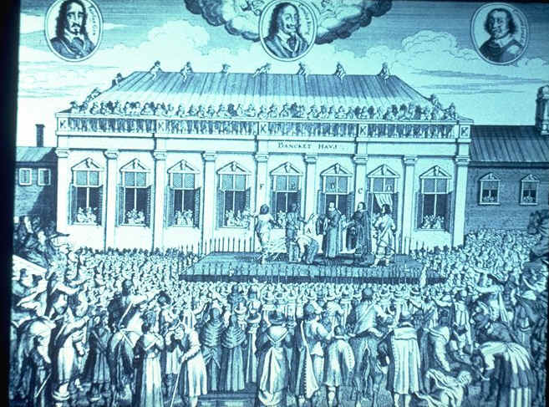
The Execution of Charles I

- What can we learn from the source about the event?
- Write a newspaper report for a) the Royalists and b) the Parliamentarians describing the event.

Your report should include the following
  - Title
  - Headline
  - Date
  - Price – 1d
  - Main Story of the event.
  - An interview with an eye witness.
  - Sketch of the event with caption.

Source A Charles I executed on 30th January 1649 outside the Banqueting Hall, London

The Royalist newspaper should give reasons why it was bad Charles I was killed.
The Parliamentarian newspaper will give reasons why it was good Charles I was killed.

