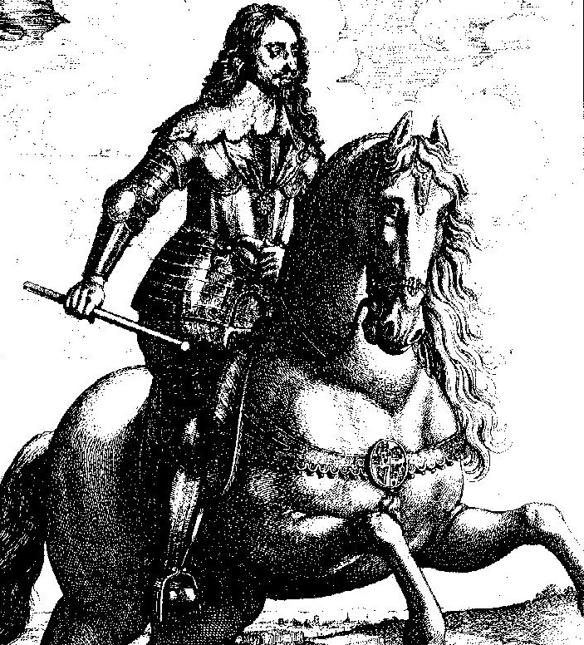
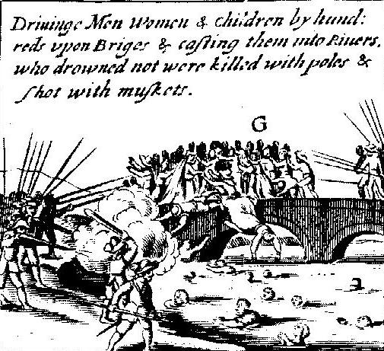
The Making of the United Kingdom 1500-1750
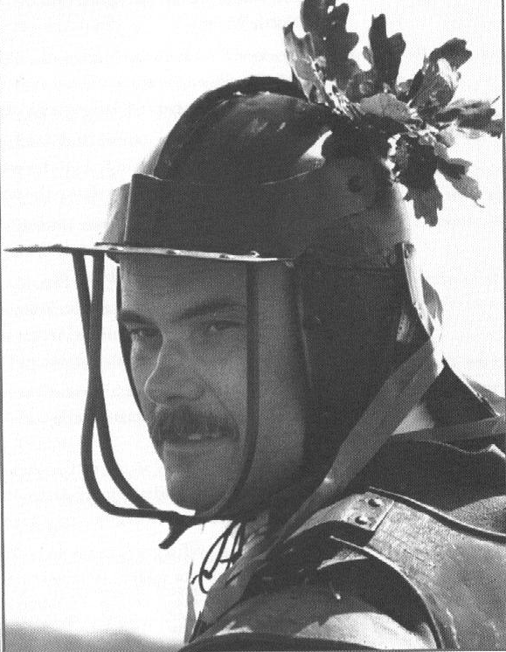
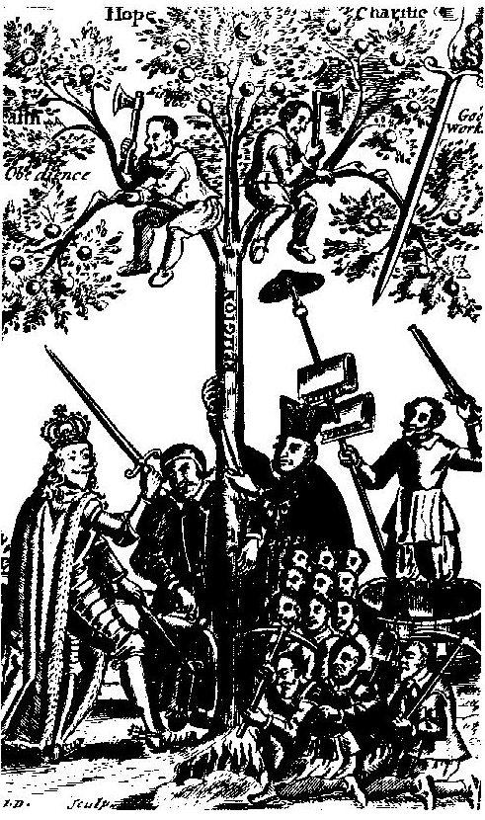
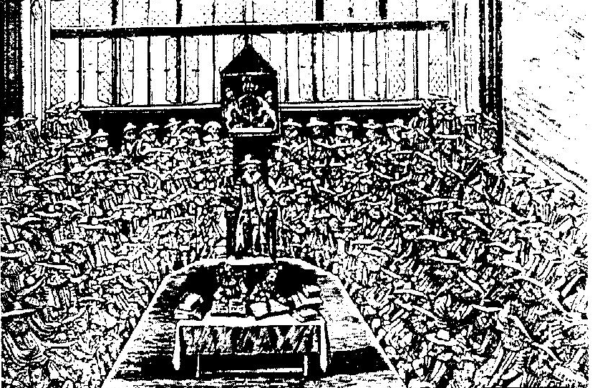
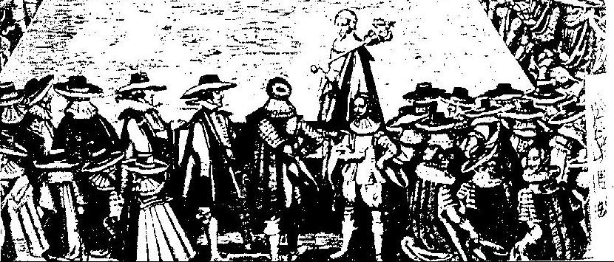
WHAT WERE THE CAUSES OF THE ENGLISH CIVIL WAR?
CIVIL WAR AND REVOLUTION!

In 1603 Elizabeth I died. She had never married and so had no children. The English throne
THE CAUSES OF THE ENGLISH CIVIL WAR
passed to James VI of Scotland, a king of two separate kingdoms as they were still not officially united. James was a Protestant (despite all previous Stuart kings and queens being Catholic – remember Mary, Queen of Scots, who had been James’s mother). As a Protestant, he was acceptable to the English people and he set up court in London on a permanent basis.

JAMES I WAS KING FROM 1603 TO 1625

HIS SON CHARLES I WAS KING FROM 1625 TO 1649.

They had taken over from Elizabeth I who had left the country peaceful, increasingly prosperous and powerful, and she herself had been a most popular monarch. Yet in 1640, only 37 years after Elizabeth’s death, PARLIAMENT (which worked with the monarch to rule the country and pass laws) WANTED TO GET RID OF THE KING, CHARLES I. BY 1642, THERE WAS CIVIL WAR.

WHAT HAD GONE SO WRONG TO TRAGICALLY DIVIDE THE COUNTRY WHEN IT LOOKED AS IF IT WOULD BECOME ONE OF THE MOST SUCCESSFUL AND POLITICALLY UNITED COUNTRIES IN EUROPE?

THROUGHOUT THE REST OF THIS BOOKLET TO THE OUTBREAK OF THE CIVIL WAR WE WILL TRY TO IDENTIFY WHAT CAUSED WAR TO BREAK OUT.

1. THE PERSONALITIES OF JAMES I AND CHARLES I.

James was a ‘rough and ready’ character despite the fine clothes that he wore. He never washed, he swore a lot, he wore padded clothes in case someone tried to stab him – but he believed that he had a God given right to rule. This idea is called THE DIVINE RIGHT OF KINGS. It meant that no one could argue with a king because that would be the same as arguing with God. In other words, the king was ALWAYS RIGHT according to this idea. Queen Elizabeth had believed this too – but she was intelligent enough not to make it a big issue in case it caused trouble, especially with Parliament. James spoke his mind and didn’t mind who he upset.

Charles I believed in this idea of divine right even more strongly. Only just over 5 feet tall, he was nonetheless a very dignified figure but who was also very reserved and had a stutter. He was also what we might call today a terrible snob! If he had met someone like you, he would have turned his nose up and averted his eyes because he would think you were so common! When Charles became king, he married a young French princess called Henrietta Maria. She was a devout Catholic and he, although still head of the Church of England, strongly sympathized with her and the Catholic faith. People began to ask in private whether Charles really was a Protestant king or whether he was trying to bring back the Catholic church.

QUESTION: Why were these two kings likely to be a lot less popular than Queen Elizabeth? Give at least 3 reasons
____________________________________________________________________________________________________________________________________________________________________________________________________________________________________________________________________________________________________________________________________________________________________________________________________________________________________________________________________________________________

2. THE KINGS’ FAVOURITES AND ADVISERS

James I and Charles I were not very good at keeping the leading nobles and gentry on their side. One of the reasons for this was because they had their favourites. From 1618 to 1628, both kings’ chief minister and favourite was George Villiers, Duke of Buckingham. Basically, he was chosen because of his good looks not because he had any special talents. All the best jobs went to Buckingham’s friends and relatives.

Parliament saw Buckingham as an extremely bad influence on Charles. He was largely behind the outbreak of war with Spain in 1625 and France in 1627. He took charge of the military operations – and he was a disaster! Both wars ended in failure and Buckingham became the most hated public figure in Britain. Finally, in 1628 he was murdered by a disgruntled army officer.

Charles was very upset by his friend’s murder. However, two new advisers took his place: William Laud, Archbishop of Canterbury and Thomas Wentworth, Earl of Strafford. Both believed in strong and strict government and heavy punishment for those who criticized the king and his rule. One such group were the Puritans who disagreed with Laud’s new church reforms. One Puritan who protested was a lawyer and MP called William Prynne. He and two other Puritans had their ears cut off and their cheeks branded for this by the order of Laud. Government appeared to be getting more harsh!
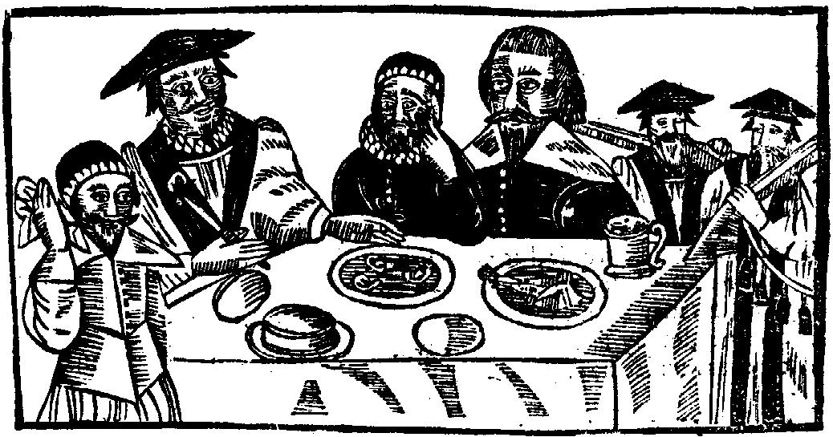
EVIDENCE QUESTION
A 17th century woodcut showing Archishop Laud eating Puritans’ ears. Is it likely to be true, and if not, why not?
______________________________________________________________________________________________________________________________________________________________________________________________________________________________________________________________________________________________
NOW READ WHAT THE TWO GENTLEMEN ARE SAYING OVER THE PAGE…
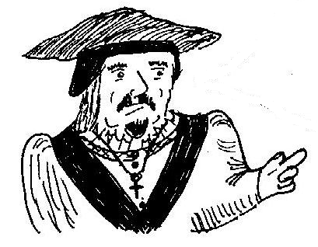
“As a member of the Protestant Church of England, I believe in obeying the King as he is head or supreme governor of the Church. Archbishops and bishops like myself run the Church as we have been appointed by God through the king. We ensure we have proper church services, wear the special clothes that priests wear to set them apart from everyone else and pride ourselves on the wealth and strength of our church. As long as people respect us and the Church, then people can work and play at whatever they wish – we have no strict rules there! However, if people criticise, disobey or abuse us, then we will punish them! This is God’s will through the Church.”

“We Puritans are very strict Protestants We don’t want all the funny regalia and wealth that the Church of England goes in for. We don’t need special churches – we can preach God’s word anywhere! We dress simply and condemn all the evil time wasting that many people go in for like drinking, feasting dancing and “having fun”! We work, study and pray hard and have no need of bishops to run the church. We do it ourselves as we are God’s chosen People to lead the fight against SIN! We obey no one but God – and if you do not listen to us, then you will all burn in hell! ”

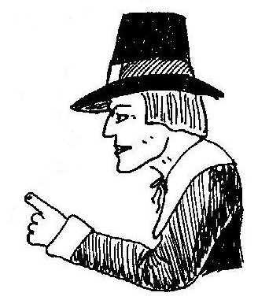

3. THE CHURCH OF ENGLAND AND THE PURITANS

You have just heard from 2 spokesmen from each church. On the chart below, show what the main differences are between them.
THE CHURCH OF ENGLAND |  | PURITANS
 | THE KING
 | GOD’S CHOSEN LEADERS
 | CHURCHES
 | DRESS
 | WORK AND ENTERTAINMENT

QUESTION. Many Puritans, because they worked hard and were often good businessmen, were becoming wealthy. This meant more and more of them were able to be chosen as MPs to sit in the House of Commons in Parliament. Say how this might increase tension between King and Parliament.
________________________________________________________________________________________________________________________________________________________________________________________________________________________________________________________________________________

4. MONEY PROBLEMS
From the words listed below, fill in the gaps.
TAXES COMPLAINED ABOUT THE CHURCH INFLATION ROWS ELEVEN RISING THE HOUSE OF COMMONS PARLIAMENT 1640

Throughout this period, prices were ______. This is called _________. Unfortunately for the monarchy, its income remained static as it relied mostly on fixed rents paid by tenants living on Crown land. Other people, like Puritan merchants engaged in trade, were increasing their incomes. So…
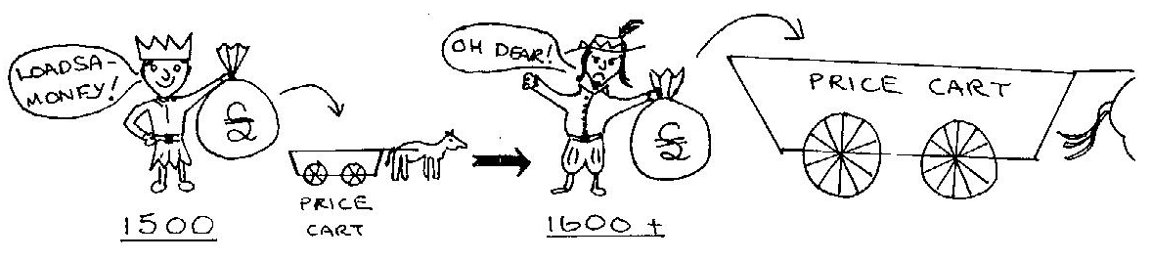

The only way that the king could get more money, especially as both James and Charles spent a lot of money, was to raise _________. For this, the permission of ________________ had to be given.

MPs in general could not control the king’s policies – the king was still by far the stronger ruler. However, over this one issue, MPs could demand certain things before granting a new tax for the king. MPs who had disliked Buckingham complained about him and Puritan MPs ___________________________________________________________________.
This often led to _______ between the king _______ ____________ ____ __________.
The king could dismiss Parliament if he wanted though and Charles did this in 1629, not calling it back again for _________ years until ________.

All what you have read and done to now has been concerned with the conditions which might have led to conflict between King and Parliament, the Church of England and the Puritans and the supporters of each. HOWEVER, THESE CONDITIONS ALONE DID NOT MAKE A CIVIL WAR INEVITABLE.

WE MUST LOOK AT WHAT HAPPENED AFTER THE KING DISMISSED PARLIAMENT IN 1629.

A. 11 YEARS RULE WITHOUT PARLIAMENT 1629-1640
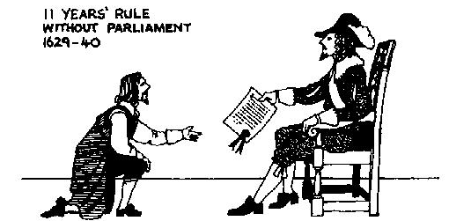
One of the king’s chief problems was to get enough money to pay for all his policies he wanted to carry out and his expensive lifestyle. Having LEGALLY closed Parliament, he could now only ILLEGALLY raise taxes. Various ways he tried to raise money was by increasing CUSTOMS DUTIES. Charles set up the old COURT OF STAR CHAMBER again (Henry VII had used this as a way to get money over 120 years before!) He used this to impose HEAVY FINES on rich people who committed crimes or even just disagreed with him! He sold titles like Sir, Baron, Earl or Knight to people to raise money. If you didn’t want a title when offered one, you were fined anyway for disobeying the king!

B. SHIP MONEY 1635
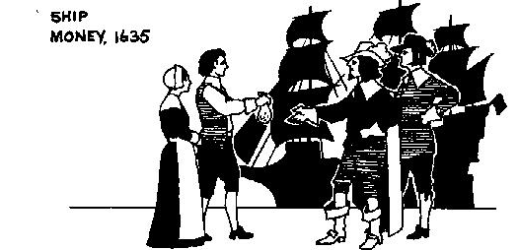
SHIP MONEY was a tax to pay for the navy. It was not a new tax but only coastal towns paid it in wartime. Charles now made the WHOLE COUNTRY pay it in peace-time. This was ILLEGAL. Although the king had supreme power, it was understood that he should respect the law – but he didn’t because he raised a tax without Parliament’s consent. Many people from gentry to ordinary town folk hated this tax. One former Puritan MP called John Hampden refused to pay the tax. He was put on trial and sent to prison. For many people, Hampden was a hero for making such a stand.
C. WAR WITH THE SCOTS 1639-40
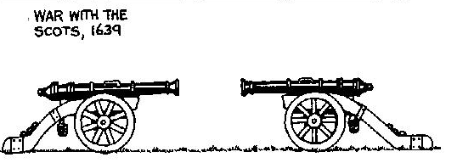
Charles tried to reform the church in Scotland in 1637 and make it more like the Church of England. He and Laud introduced a new Prayer Book and services. The Scots hated it. They rioted and rebelled and in 1639, a Scottish army invaded England. This was a dangerous crisis for Charles. He needed money to quickly raise an army to fight the Scots. He recalled Parliament in 1640 to vote him money. Instead, Parliament complained of their treatment over the past 11 years. Charles dismissed Parliament yet again.
The war with the Scots was disastrous. In the end, Charles signed a truce and agreed to pay the Scots £850 a day. To get the money, he recalled Parliament.

D. THE EXECUTION OF STRAFFORD, 1641.
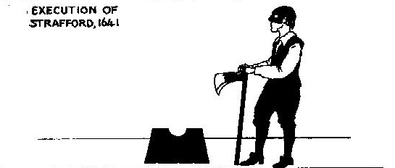
The king was in no position to argue with Parliament now. John Pym, the Puritan leader of the House of Commons, had both the King’s advisers Strafford and Laud arrested for high treason for giving the king bad advice. Strafford was executed. Parliament forced concessions, reversing all the unpopular actions introduced since 1629. Parliament also said that the king could not dismiss Parliament without the consent of Parliament. The King had to agree to all this to avert disaster. Parliament and King now began to work together once again but relations between the two were very strained.

E. REBELLION IN IRELAND 1641.
A rebellion of Irish Catholics against English Protestant settlers broke out. Many Protestants were murdered and so, an army needed to be raised to put down the rebellion. The King said he would lead it – but many members of Parliament led by Pym did not trust the king to just use the army against the Irish. Pym said that Parliament would appoint the general for the army.

F. CHARLES TRIES TO ARREST 5 MPs 1642.
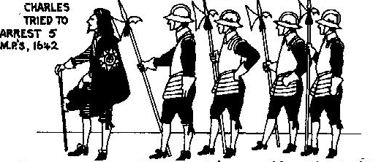
Outraged by this, Charles made a fatal mistake. He marched into the House of Commons with an armed band of soldiers to arrest 5 MPs including Pym. They had escaped just before Charles arrived. Charles made his famous remark, “ I see the birds have flown.” Parliament now knew it could no longer trust the king. Charles left London to seek armed support to fight Parliament and force it to do as he said. At Nottingham in August 1642, the king raised his standard (royal flag) signaling his declaration of war against Parliament. THE CIVIL WAR HAD BEGUN
NOW ANSWER THE FOLLOWING.
1. Choose one of King Charles’ actions to complete this sentence:

“Charles I’s attempt to rule without Parliament was doomed to fail when he___________________________________________________________________________________________________________________________________________________________________________________________________________

2.a. Why do you think Parliament charged the king’s advisers of high treason rather than the king in 1641?
____________________________________________________________________________________________________________________________________________________________________________________________________________

b. Who had Charles made enemies of by 1642? Make as comprehensive a list as possible
________________________________________________________________________________________________________________________________________________________________________________________________________________________________________________________________________________

3. Make a chain of causes of the war in the boxes below from 1629 to 1642. In each box, BRIEFLY write the event, the date and a description.

