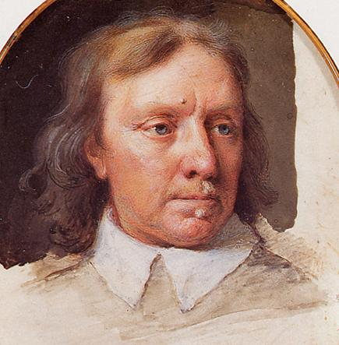
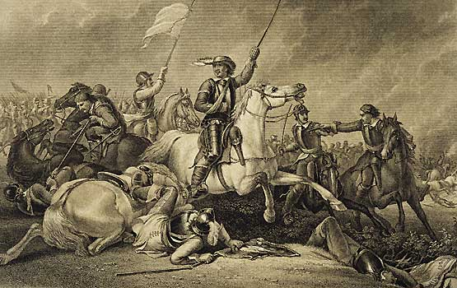
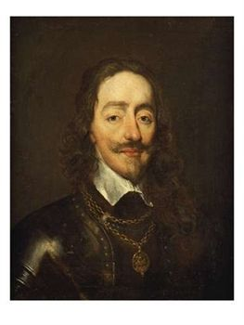
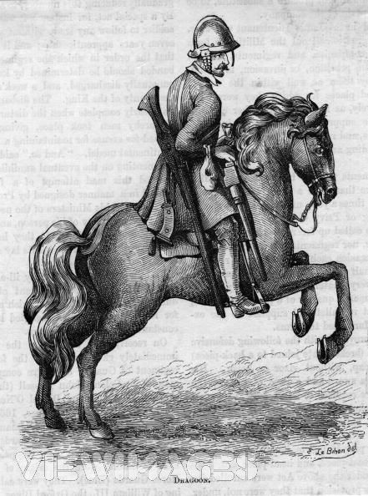
CROMWELL
CHARLES I
Charles R
Oliver Cromwell
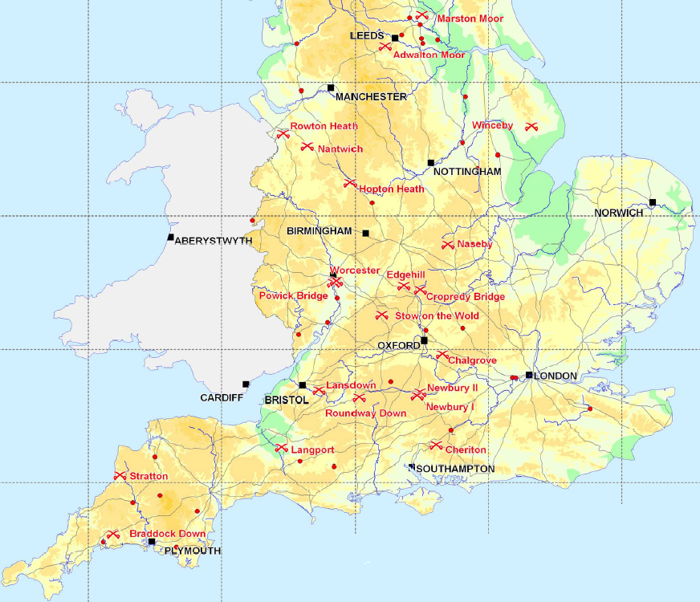
1642
1651
CIVIL WAR
NAME/FORM:

THE CIVIL WAR 1642-1651

Civil War is a war between two or more sides in one country. It usually happens because people violently disagree about how the country should be governed, or because good government breaks down. As we have seen, this had happened in England by 1642. Parliament would no longer do as the King said and the King could not persuade Parliament to change its mind except by force. Civil war is a tragedy for a nation – it not only wastes life, property and industry, it DIVIDES a nation against itself in the most violent way. In many ways, civil war is probably the worst type of war.

There were, in fact, THREE civil wars in Britain:

THE FIRST CIVIL WAR OF 1642 TO 1646

THE SECOND CIVIL WAR OF 1648
THE THIRD CIVIL WAR OF 1651

The first civil war is the most important and is the one mostly dealt with here.

TAKING SIDES

We must remember that people had to be recruited or persuaded to join one side or the other as there were no full time professional armies like today to do the fighting. Hence the king in 1642 travelled the country drumming up support before he raised his standard at Nottingham. Parliament equally did the same for itself!

There were two sides:

ROYALISTS, sometimes called CAVALIERS, who supported the KING.

PARLIAMENTARIANS, sometimes called ROUNDHEADS, who supported PARLIAMENT.

Below are two pictures of cavalrymen (soldiers on horseback) – a Cavalier and a Roundhead.

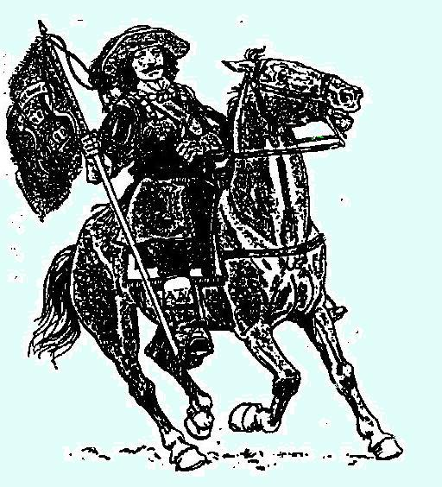
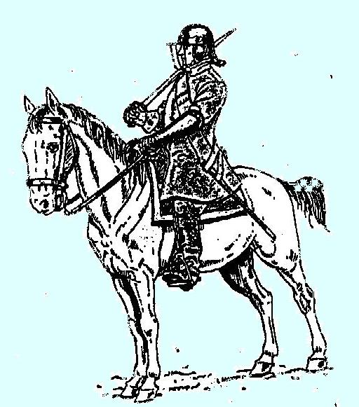
CAVALIER
ROUNDHEAD

How accurate are the terms “Cavalier” and “Roundhead” though?
 | ORIGIN | ORIGINAL MEANING | LATER MEANING
CAVALIER | From Spanish word – “cavaliero” or a soldier on horseback | A brutal Spanish Catholic trooper and enemy of the Protestants | A gallant and free-and-easy gentleman
ROUNDHEAD | Nickname given to the London apprentices who had their hair cut very short | The MP John Pym had used apprentices as a “mob” outside Parliament to support him in his attacks on the King. Royalists then called Parliamentarians “Roundheads”. | A Puritan soldier under the command of Oliver Cromwell, a Parliamentary general and later Britain’s ruler.
NOTE: Most soldiers on both sides wore their hair long!

What were the nicknames meant to be – friendly, abusive, critical, easy to use, affectionate? (Cross out the ones you disagree with).

How accurate do you think these names are? Explain your answer.
________________________________________________________________________________________________________________________________________________________________________________________________________________________________________________________________________________

Give a reason why an original meaning might change to a different one later on (as the Cavalier one did)._____________________________________________________________________________________________________________________________________________________________________________________________________________________________________________________________________________

Despite all this, if you were on a battlefield, it would be useful to distinguish between the two! For each of the pictures, choose 2 main things that identify them as being one or the other – do NOT say differently coloured horses!

CAVALIER: 1. __________________________________________________________
2.__________________________________________________________

ROUNDHEAD: 1.________________________________________________________
2.________________________________________________________

Look at the poster and map on the next page which gives information about who supported who in the civil war. From what you know of the origins of the civil war, put which side – ROYALIST or PARLIAMENTARIAN – represented who at the top of the appropriate list.
Then shade in the map of England to show where support for each side was. The dividing line between the two is already drawn. Remember to do a key.

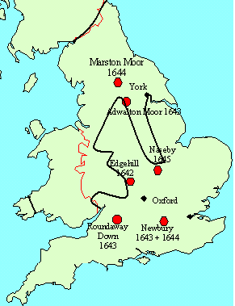
A CONTEST
TO DECIDE WHO WILL RULE THE COUNTRY
V

THEIR SUPPORTERS
CHURCH OF ENGLAND PURITANS
AND CATHOLICS

NOBLES AND MERCHANTS AND
COUNTRY GENTLEMEN BUSINESSMEN

THE NORTH AND WESTTHE SOUTH AND
OF ENGLAND AND WALESEAST OF ENGLAND

COUNTRY AREASLONDON, LARGER TOWNS AND PORTS.

SHADE IN THE TWO AREAS SUPPORTED BY EACH SIDE – IN DIFFERENT COLOURS!

HOWEVER… as always in history, things are not quite as clear cut as they seem. Although the lists above are generally correct, some people were sympathetic to Parliament yet fought for the King and vice versa. For example, there were many country gentlemen and some noblemen who fought for Parliament. Families often split with father and son or brothers on opposite sides. Many of the poorer people like farm labourers had to go along with whoever was controlling their area of the country or support whoever their landlord supported. Often people swapped sides as armies moved across the country – for obvious reasons! Many MPs fought for the King. For example, in 1641, John Pym introduced a long list of complaints about the misdeeds of the King called the “Grand Remonstrance”. It was only approved by 159 to 148 votes – a majority of only 11! Even Parliament was divided over being too hard on the king. Women, rich and poor, were mostly neutral and didn’t pick sides. Indeed, many well off women had to defend their homes from long sieges by both sides when their husbands and sons were away fighting, showing great strength of character in a war they hated.

Why do you think most women were neutral about or just plain hated the war?
____________________________________________________________________________________________________________________________________________________________________________________________________________

What sorts of reasons might affect a person’s choice of sides in the war?
Make a list.___________________________________________________________
________________________________________________________________________________________________________________________________________
____________________________________________________________________
____________________________________________________________________
____________________________________________________________________
____________________________________________________________________
____________________________________________________________________

The Verney family was split by the war. Sir Edmund Verney decided to support the king: his son, Sir Ralph, supported Parliament.
Sir Edmund told a friend:
“For my part, I do not like the quarrel and do heartily wish that the king would consent to what they desire. I have served him for thirty years and will not do so base a thing as to desert him. I have no liking for Bishops for whom this quarrel is fought.”

Question: Why does Edmund sympathise with Parliament
but support the king?
__________________________________________
__________________________________________
__________________________________________
__________________________________________
__________________________________________
__________________________________________
__________________________________________
__________________________________________

“God knows with what a sad heart I go upon this service and with what a perfect hatred I detest this war without an enemy… but… we are both set upon a stage and must both act those parts given us in this tragedy: Let us do it with honour and without personal dislike.”

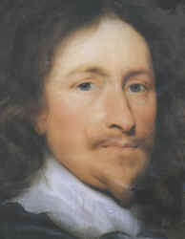
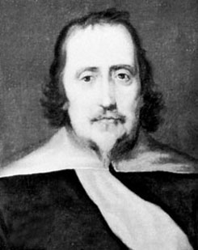
SIR WILLIAM WALLER
SIR RALPH HOPTON

Before the war, both Sir Ralph Hopton and Sir William Waller were close friends. Both became generals on opposite sides. Sir William said this in a letter to Sir Ralph in June, 1643:

Question: Why does he call the war, “this war without an enemy”?
____________________________________________________________________________________________________________________________________________________________________________________________________________
The Earl of Manchester was a leading Parliamentary general. He once said this:
“If we beat the King ninety and nine times, yet he is King still…
but if the King beat us once we shall all be hanged.”
Question: What does this say about who is the rightful ruler and why?
________________________________________________________________________________
____________________________________________________________________________________________________________________________________________________________________________________________________________

HOW THE SIDES FOUGHT

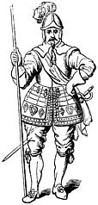
Both sides used similar tactics (or ways of fighting a battle) and both sides had 3 main types of soldier:
THE PIKEMAN: He held a long pike or pointed pole.
His job was to:

(a) protect the musketeers
(b) break up cavalry charges
(c) advance forward in groups like a ‘hedgehog’ to attack the enemy – see below.

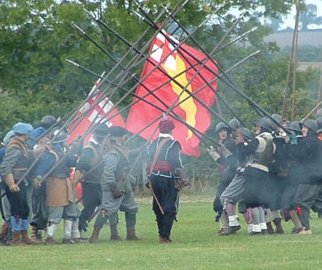
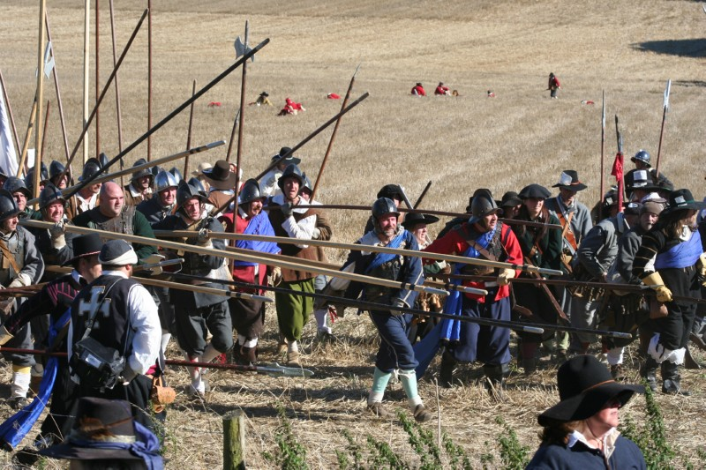

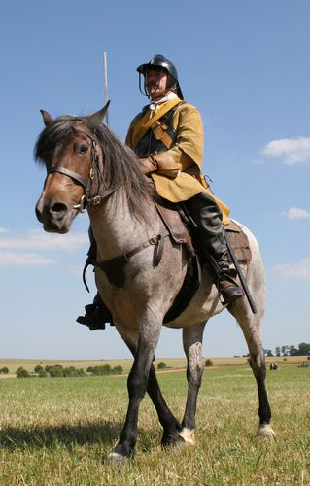
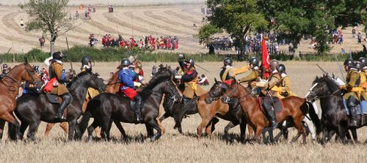
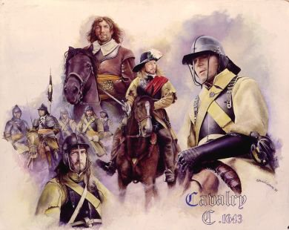
THE CAVALRYMAN: He used a sword and matchlock pistol.
His job was to charge the enemy ‘en masse’ to break up, chase off or destroy cavalry and infantry (soldiers on foot).
This picture above is of a Parliamentary cavalryman.

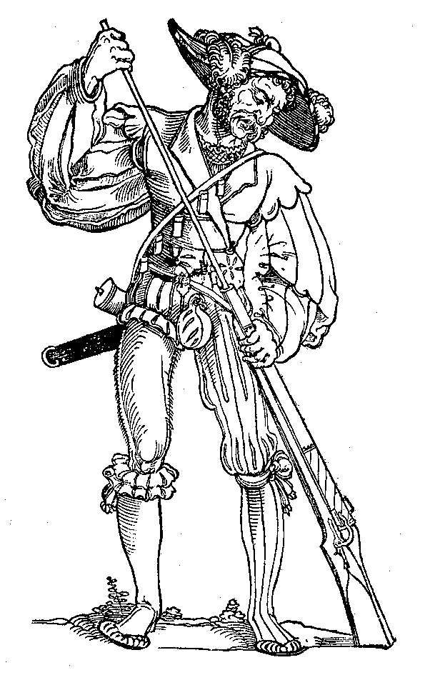
THE MUSKETEER: He used a heavy matchlock musket ( an early ‘rifle’) which was not very accurate and was slow to reload. It was effective when fired as a volley of many shots.
His job was to:
(a) shoot long range at the enemy
(b) help the pikemen move forward
(c) use his musket as a ‘club’ in close combat!

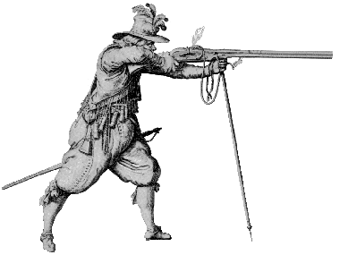

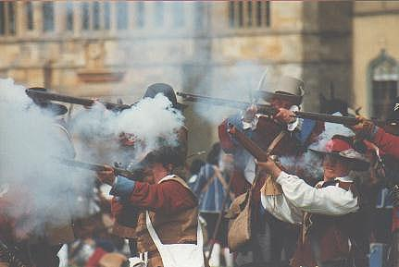
This picture shows Royalist musketeers in action

NOTE!
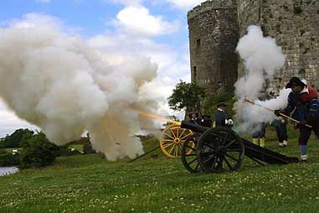
Cannons were used too. They were heavy and difficult to move and had to be pre-positioned before a battle to gain maximum effect.

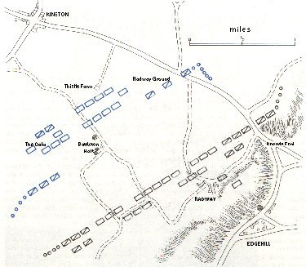
Key: Roundheads are blue, Royalists are shown in black.
Cavalry
Infantry
Dragoons
Cannon
Opposite is a plan of how the forces lined up against each other at the first battle of the war at Edgehill in Warwickshire. The way troops were laid out did not change much during the war – with cavalry at the sides or flanks and the infantry in the middle, with cannon either in between or behind the troops. (Dragoons are infantry on horseback, occasionally fighting on foot and horse). From this and from what you know of the 3 main types of soldier, what would you do first if you were leading the King’s army:

a. Move your pikemen forward;
b. Attack with your horsemen
c. Order your musketeers to fire?

Write down your choice and your reasons for it.
____________________________________________________________________________________________________________________________________

________________________________________________________________________________________________________________________________________________

CASE STUDY: THE BATTLE OF EDGEHILL 22nd OCTOBER 1642.

A lot of the fighting in the war consisted of skirmishes or very small battles, and sieges where a town, castle or country house was surrounded to try and force it to surrender by cannon bombardment, mining or starvation. However, the outcome of the war was really decided by big battles. Edgehill, fought near the village of Kineton on the Warwick to Oxford road in Warwickshire was the first.

Battles then were very different from those today, not just in weapons but also in tactics. AS you can see above in the plan, forces had to be laid out like chess pieces, usually in full view of the opposing army. Before this happened, it could take weeks or months for roving armies to meet up. Remember that communication was poor – the fastest communication was by letter on horseback. By the time an army was sighted and the news passed to the opposing army, things would have changed and the army moved again! Often, battles happened by chance or at key strategic points. Once battle was to begin, then a time might be fixed to start the battle – but as few people had clocks, let alone watches, then times were flexible and often ignored. So, although forces were laid out carefully beforehand, once battle commenced, because of lack of timings and good communications, the battle could become very chaotic. Officers and sergeants could only be identified by coloured ribbons or sashes attached to their coats (the origin of modern badges of rank) and often soldiers could only be identified by the flags each company of men carried. Unless soldiers were well trained and drilled, a commander could easily lose control of the battle. Needless to say, battles were brutal and bloody and were usually won in the end by sheer effort of will in hand-to-hand combat.

AND SO TO EDGEHILL…… The following account is based on eyewitness reports of the time.
The Royalist army commanded the King and his nephew, Prince Rupert of Bavaria, were marching to Oxford (the only city to remain loyal to the King throughout the war) and, ultimately, London, the main Parliamentary stronghold. If they could take London, the Royalists would win the war. The Parliamentary army, under the command of the Earl of Essex, was trying to stop them. The two armies were very evenly matched. The King occupied Edgehill itself, a high ridge overlooking the plain below, on which the Roundheads were. Essex refused to attack uphill. Hence there was a delay. Eventually, for battle to begin, the King’s army moved down onto the plain and lined up as on the plan. Battle began in the afternoon when Essex opened fire with his cannon. Prince Rupert charged the Parliamentary cavalry on the right and swept it from the field, chasing it as far as Kineton. Rupert’s cavalry did not return until much later. In the meantime, the infantry were locked in battle, and the Roundheads were gaining the upper hand with the use of their remaining cavalry. The Royalists were pushed back to Edgehill, their guns were put out of action and the Royal Standard captured. Rupert arrived back just in time to save the infantry from being beaten. By this time, it was dark and both armies were exhausted. The Royal Standard was recovered for the King and both armies retired from the battle, the Royalists holding Edgehill and the Roundheads retreating to Warwick.
Sir Edmund Verney had fought in this battle and, as he said he would, he remained loyal to his king. He was killed while holding the Royal Standard. His hand still clung to it where it had been cut off.
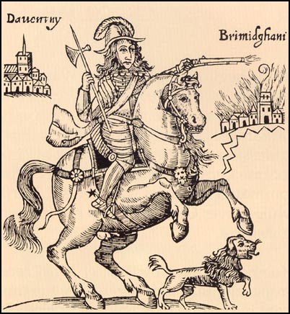
QUESTIONS: Why do you think Essex refused to attack uphill?
PRINCE RUPERT
_______________________________________________________________________________________________________________________________________

Do you think Rupert made a mistake when he chased away the Roundhead cavalry? Give your reasons.
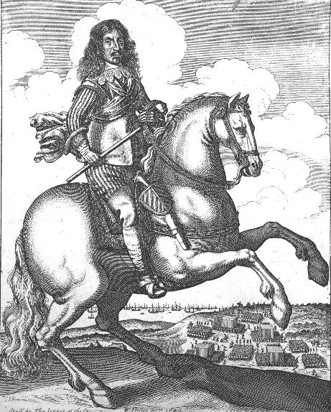
____________________________________________________________________________________________________________________________________________________________________________________
THE EARL OF ESSEX

Who, in your opinion, won the battle?____________________________________________________________________________________
TASK: Watch the video clip from the feature film “CROMWELL” of the battle. After you have seen it, note down on a separate sheet anything that is RIGHT and anything that is WRONG about it from what you already know. DISCUSSION POINT: What are the advantages or disadvantages of reconstructing history on film – especially Hollywood films?

WHY DID PARLIAMENT WIN THE CIVIL WAR?

After Edgehill, Oliver Cromwell, an East Anglian farmer and MP and now a leader of the Parliamentary cavalry, said this to his cousin, John Hampden.
“Your troopers are most of them old, decaying serving men and tapsters (barmen) and such kind of fellows and… their (the Royalists’) troopers are gentlemen’s sons, younger sons, persons of quality. Do you think that the spirits of such base and mean fellows will ever be able to encounter gentlemen that have honour, courage and resolution in them? …. You must get men of a spirit… that is likely to go on as far as a gentleman will go, or else I am sure that you will be beaten still”.

IN SHORT, THE PARLIAMENTARY ARMY HAD BETTER GET ITS ACT TOGETHER – OR LOSE!

After all, the King seemed to hold most of the aces. He was supported by some very wealthy men, so he had money. The quality of his fighting men was generally high. He only had to take London to win the war – while Parliament had to take most of the country. As we have seen, many people on Parliament’s side were reluctant to fight the king and so their willingness to go all the way for an outright defeat of the King was not to be counted on. It is little wonder that Cromwell was worried!

But look at the maps below showing the territory controlled by both sides to 1645:
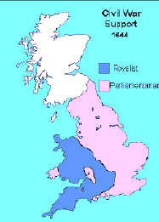
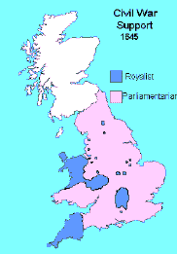
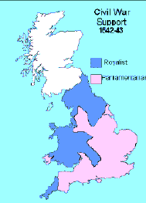
Two significant battles – Marston Moor in the North in 1644 and Naseby in the Midlands in 1645 – had proved decisive victories for Parliament and by 1646, PARLIAMENT had essentially WON the first civil war.

How had this come about after Edgehill?

In your exercise books, write a short essay which answers the question, ‘Why did Parliament win the Civil War?’ ( a minimum of two sides; a maximum of four). Use the following aspects of the war to help you answer. Explain why Parliament was able to get the upper hand and defeat the Royalists by 1646, using the information to support your answer. You must use your judgement based on your understanding of the evidence to show which of the factors leading to victory were the most important and why.

Money – first, London, the most important city in England and Wales, and the South East of England were never taken by the King. Both were rich in money and resources and very populous – this meant they could hold out for a long time and keep the Parliamentary armies supplied with men and money. New taxes were raised by Parliament and, because the South East never changed hands, this meant that Parliament had a ‘captive audience’ of tax payers. Parliament was very good at regular collections of taxes too. The King with his court at Oxford found it difficult to do this as he was cut off from the traditional centre of government in London.

As each year passed, the King’s money dwindled away until, after the battle of Naseby, he had no more with which to raise another army. Charles would have done well to march on London after Edgehill. As it was, he stalled and went westwards – perhaps a fatal mistake in the long term.

The Navy remained loyal to Parliament too – mostly because it was well paid and equipped to protect the merchant ships that were still trading with Europe and the New World. As most shipping traded from London, then again it brought in money to Parliament’s cause with little disruption. The Navy could also be relied upon to fight an invasion force of foreign troops that the King may have called to help him.

The Scots – in 1643, Parliament made a deal with the Scots. It said it would set up a Scottish style church in England if it helped it win the war. The result was that a joint Scottish and Parliamentary army beat the Royalists at Marston Moor in Yorkshire in July 1644 and so secured control of the North.

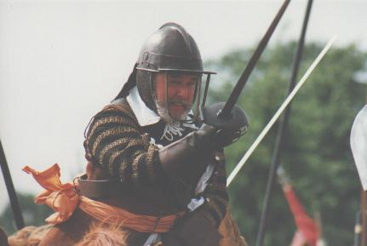
New officers – in 1645, Parliament made a rule called the Self Denying Ordinance. It said that no member of the House of Lords or Commons could continue to be an army officer. On the surface, this looks like a sensible measure to make sure that MPs do not automatically get the top jobs in the army but would have to work for these positions on merit alone. In fact, it was to get rid of all those who were reluctant to continue fighting the king. Essex and Manchester lost their positions – but Cromwell kept his as an exception. He became leader of the Parliamentary cavalry. Sir Thomas Fairfax, an experienced soldier, took over the whole of the army. Many other new officers were appointed and all were professional, ruthless and determined to defeat the King. Previously, there had been three Parliamentary armies – now all were united in one new organization…
Two shillings a day!
And the Lord of Hosts is with us!
Why the New Model Army always won

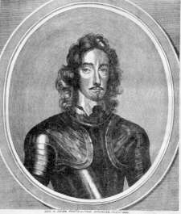
The New Model Army – or the ‘New Noddle Army’ as the Royalists called it. They soon had to change their tune, It proved very successful. It was decisive at the battle of Naseby in June 1645. The main reasons are given opposite of why it was so successful. It also provided what Cromwell had said he wanted after Edgehill: “I want men of middling rank who, being well armed within by the satisfaction of their conscience (belief in their cause) and without by good iron arms (effective weapons), they would, as one man, stand firmly and charge desperately.”
Top quality weapons
First rate training and discipline.
Regular pay (except in 1647). The army cost about a million pounds a year
Sir Thomas Fairfax
(1612-71) Yorkshire Parliamentarian and commander of the New Model Army. Sir Thomas was among the bravest and most accomplished generals of the war.
Cromwell now had no cause for complaint.

Popular discontent with the war – by 1645, many people were fed up and they wanted it to end. People were tired of all the arguments for and against in all the new newspapers that were being published; they were tired of the bloodshed, heavy taxation and general disruption; they were fed up of being made to give food and shelter to troops, of seeing crops and buildings destroyed or looted. After all, the majority of the population – women, children, the older men, the merchants, craftsmen and farmers – were not in the army but all were affected by it. In short, people had had enough.

SOME EVIDENCE OF THE TIME THAT HIGHLIGHTS POPULAR VIEWS OF THE DIFFERENT ARMIES
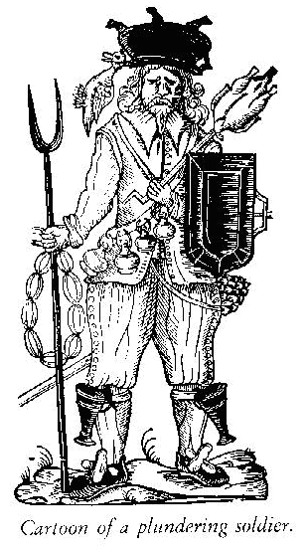
- A cartoon from the civil war showing a pillaging soldier.
Instead of a musket he holds a goose on a spit;
There are bottles of wine on his gunpowder belt;
His shield is a dripping pan;
He has an artichoke for a sword and black pots for garters;
On his head he has a cooking pot decorated with a duck!

What is this cartoon trying to say about the average soldier?
____________________________________________________________________________________________________________________________________________________________________________

- Below are 2 pictures from newspapers of the time. Say which side drew which picture and say which one is likely to be more accurate and why.
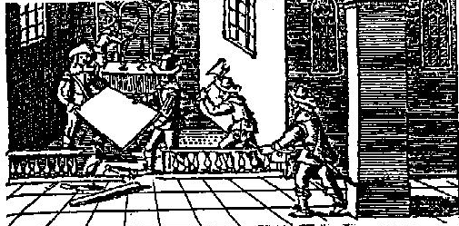
A

Parliamentary Puritan soldiers dismantling a church.

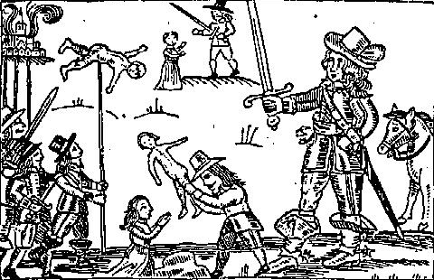

B

Royalist treatment of civilian prisoners after taking a town.

____________________________________________________________________________________________________________________________________________________________________________________________________________________________________________________________________________________________________________________________________________________________________________________________________________________________________________________________________________________________________________________________________________________________________________________________________________________________________________________________________________________________________________________________________________________________________________________________________________________________________________________________________________________________________________________________________________________________________________________________________________________________________________________________

QUESTIONS:
What types of soldier are shown at:
Point G?_____________________________________________________________________
Point H?_____________________________________________________________________
Point J?_____________________________________________________________________
Who do you think the people are watching at point K?____________________________________ ___________________________________________________________________________
What do you think is at point L? (Clue: the New Model Army has one too) _____________________ ___________________________________________________________________________
What is similar and what is different in this battle from Edgehill (apart from the fact that Parliament won!). Give at least 2 of each.
____________________________________________________________________________________________________________________________________________________________________________________________________________________________________________________________________________________________________________________________________________________________________________________________________________________________________________________________________________________________________________________________________________________________________________________________________________________________________________________________________________________________________________________________________

CASE-STUDY: THE BATTLE OF NASEBY 14th JUNE 1645

This battle was fought in Northamptonshire and was a decisive victory for the New Model Army. You can see the layout of the battle from the primary source picture below. The two armies took up position on two gently rising hills, the New Model Army to the south near Naseby village. The distance between them was about a mile and the ground was boggy and covered in furze bushes making it difficult for cavalry to maneuver. Parliament had about 14,000 men and good morale, and the Royalists had up to 11,000 men and were suffering from poor morale despite being battle hardened.

KING CHARLES, GENERAL FAIRFAX AND CROMWELL CAN BE SEEN AT POINTS A, B AND C RESPECTIVELY.

The Royalist army attacked first, with PRINCE RUPERT (see point D) attacking Parliament’s left flank. This was broken by Rupert who chased most of the cavalry on the left to the baggage train (at point E) and was off the field of battle for some time. On the right though, Cromwell charged downhill and broke the Royalist left flank. Cromwell kept regrouping his well trained cavalry to attack and attack again, and then he attacked the infantry in the centre. Helped by Parliamentary dragoons who had been concealed behind a thick hedge waiting for the right moment to attack (see point F), the Royalist centre collapsed. By the time Rupert returned, the battle was over and the King defeated. It had taken just 3 hours – and 5000 Royalist prisoners were taken along with all their equipment. What is more, letters from King Charles to his wife revealed that he had been trying to bring over an Irish Catholic army to fight Parliament. This now turned a lot of opinion very strongly against the King.

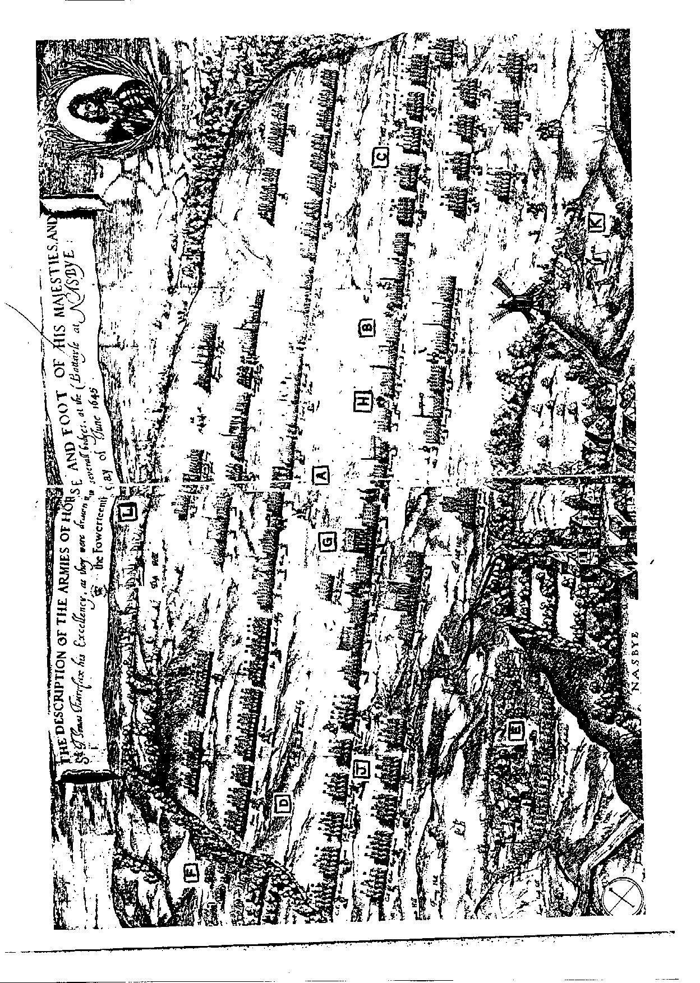
THE WARS CONTINUE

King Charles surrendered to the Scots in 1646. In turn, the Scots handed him over to Parliament who tried to negotiate an agreement with him. This took a long time. In the meantime…

THE NEW MODEL ARMY HAD BECOME A STRONG POLITICAL AS WELL AS MILITARY FORCE. The soldiers had seen that they were as good fighters as gentlemen and had saved Parliament. Parliament refused to pay them overdue wages in 1647. The army, along with Fairfax and Cromwell, no longer trusted Parliament. It refused to go to Ireland to put down a rebellion there (although it did go once it was paid). In 1647, a junior officer captured the king for the army and the army started its own negotiations with him. Charles tricked them though and secretly negotiated with the Scots to fight a new war on his behalf in return for setting up a Scottish Presbyterian church system in England. The Scots agreed and, aided by Royalists in England, a Scottish army invaded in 1648. THIS WAS THE SECOND CIVIL WAR. Cromwell marched North with the New Model Army and soundly defeated the Scots at Preston in Lancashire. The Second Civil War was over.

The army could no longer trust the king. It saw him as a ‘man of blood’ and a traitor. He had to be put on trial for his crimes. The army, under the direction of Colonel Pride, purged (got rid of) those MPs who wanted to negotiate with the King (“Pride’s Purge”) and put King Charles on trial in Parliament. Almost inevitably, he was found guilty of treason. KING CHARLES I WAS EXECUTED IN LONDON IN JANUARY 1649.
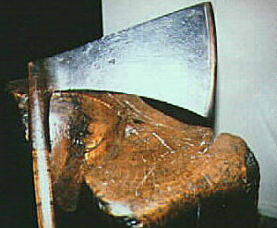
England was now effectively run by the army and the ‘purged’ Parliament – known as the Rump. Charles I’s son, CHARLES STUART NOW CLAIMED THE THRONE, CALLING ON THE SCOTS, THE IRISH AND ENGLISH ROYALISTS. THIS WAS THE THIRD CIVIL WAR.
Cromwell brutally put down the Irish and any Royalist rising. The Scots were again defeated on the Scottish borders at Dunbar in 1650. CHARLES STUART, NOW CALLING HIMSELF CHARLES II, RAISED ANOTHER SCOTTISH ARMY AND AGAIN INVADED. THEY GOT AS FAR AS WORCESTER WHERE THEY WERE DEFEATED BY CROMWELL IN 1651. Charles escaped to France, courtesy, as legend has it, of the concealing qualities of many oak trees! THE THIRD AND FINAL CIVIL WAR WAS OVER.

Britain now had no king. The strong New Model Army and the remains of what was Parliament now ruled. The Puritans now had the upper hand. Oliver Cromwell had emerged as the most powerful man in the British Isles. The country had been ravaged – out of a population of just over 5 million, of which 1.5 million were adult males, 84,738 people had been killed.

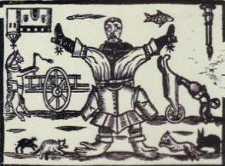
BRITAIN WAS NOW A WORLD TURNED UPSIDE DOWN. WHAT WOULD HAPPEN NOW?

