PLAGUE DIARY

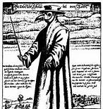
You are a Goldsmith living in London during the Great Plague of 1666. Write three diary entries to cover the following events:

2nd June 1665 – The Plague
begins to spread through the city.

10th August 1665 – Your son dies of
the plague.

1st September 1665 – Celebrations for the
end of the plague.

Feel free to embellish your pages with illustrations!

