The Big Story of America
Throughout your GCSE unit on the Making of America, you will be developing an understanding of the story of the United States 1789-1900. You will see how different groups of people had visions and imaginings which shaped and were shaped the land of America.
As you start the course, you should read over this big overview story. The better you know this story, the more easily you will be able to attach new knowledge to it. It will act a bit like a washing line that you can peg your knowledge to.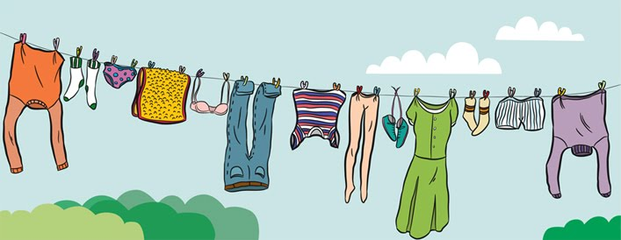
Key people, dates and events
The Story
You should come back to this story regularly to see where new content fits in.

Chapter 1: America begins to grow, 1789–1838
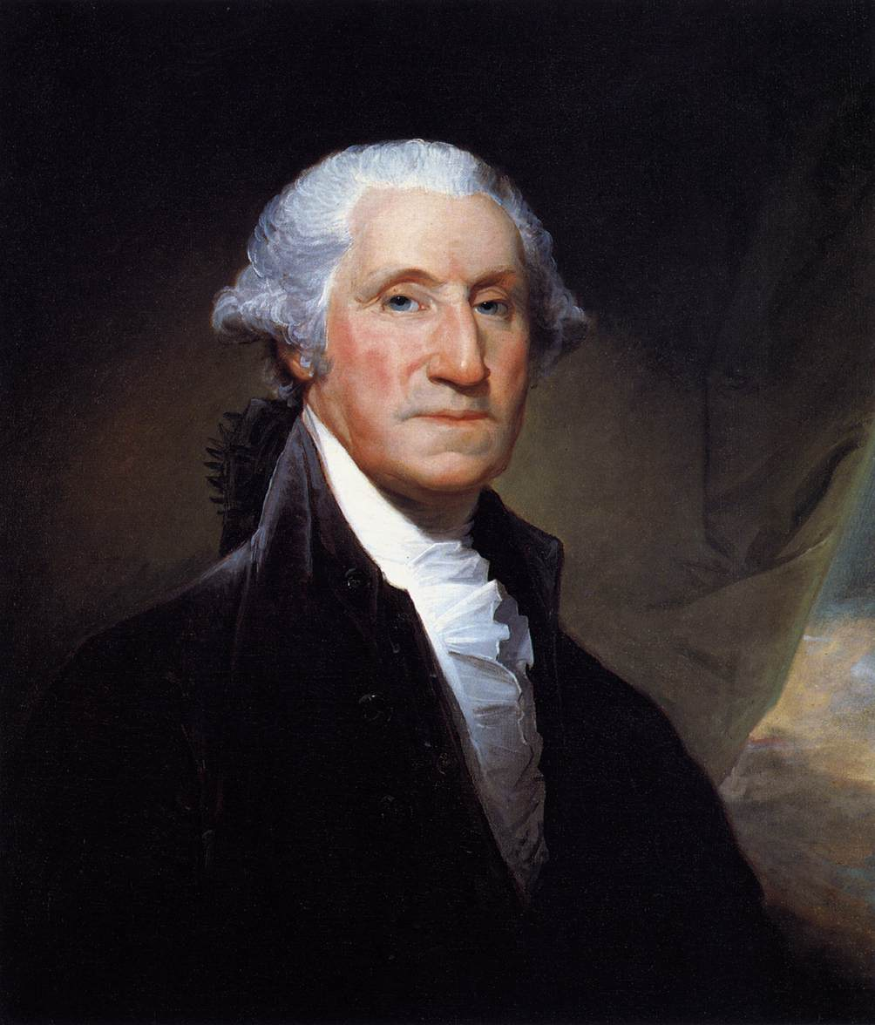
The USA was a new country in 1789. It was made up of 13 states and had only just elected its first President. People were not really sure if the USA would survive because it had to share the land with other European empires and the native Indians who lived there already.
At this point, being a US citizen meant being white. Indigenous peoples and black Americans were not allowed to be citizens. Men with property could vote in elections, but men without property, and women, could not vote.
Even at this early stage the USA was quite divided. People had competing visions about what they thought America should be. They were also divided over issues such as: slavery, the economy and ways of life. People in Northern States were generally against slavery and believed in modern business and industry. People in Southern States generally supported slavery and believed in farming and living a good Christian life. Many early Presidents saw their role as keeping a balance between the two sides.

Growing in the Northwest
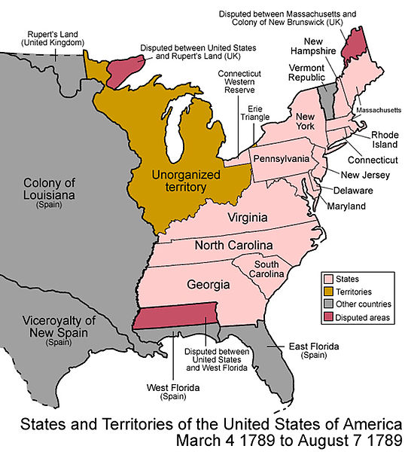
Between 1789 and 1838 the US expanded quickly in the Northwest. The government encouraged this because they were afraid that a “new” country might be defeated by other European empires or by Native Americans hoping to take back some of their lands. America also expanded because many Northern Americans had visions of owning their own land. This would allow them to be self-sufficient, pursue opportunities, and be able to vote for the government. Businesses wanted to expand to increase trade and make money.
The colonisation of North America by the USA opened up lands for farming in the North as they were taken from the Indigenous populations. This led to conflict with Native Americans nations who were defending their homelands.

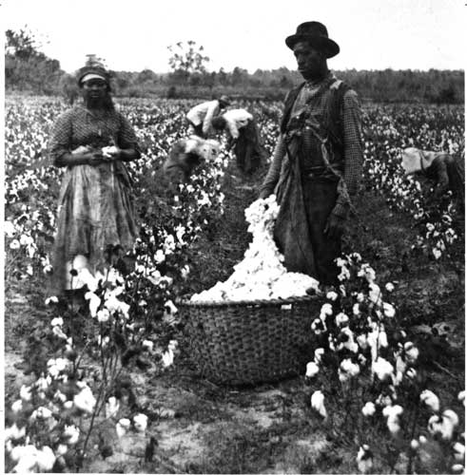
Growth in the South and slavery
America also began growing rapidly southwards after 1790. This growth was pushed by slave holders who had visions of converting the hot southern lands to produce cash crops like cotton and tobacco. Many Southern slave holders believed that America should be a land where slavery was encouraged and where political power was in the hands of powerful land holding families. Many Southerners also saw their way of life as very different to the North – based on ideas of “honour” instead of industry and money making.
The slave trade grew as America grew. Northern businesses also put a lot of money into funding these new plantations. New technology allowed cotton to be processed more quickly; and many people were willing to try and get rich by buying and selling enslaved black people. Northern banks often loaned the money needed for Southern slave holders to buy other humans. At the same time the growth of plantations led to conflict with Native American peoples already living in the South.
By 1840 the USA was the world’s biggest producer of cotton. This meant that the price of cotton actually fell and enslaved people had to work harder so that their owners could make enough money. Plantation owners brought in a new work system called the “pushing system”. This system punished slaves who did not work faster every day. Some people in the North were shocked at how awfully the enslaved were treated, but only a few!
Many people in the North were worried that the Southern states were becoming too powerful as enslavement made them more and more money. However, the money from cotton made Northern business owners rich too.

Native Americans in the South
By the 1820s there were five Native American nations in the South who were reimagining their own visions of the land and their place. Rather than fight the expanding Americans, they tried to live alongside them. Some of these nations converted to Christianity, wore US-style clothes, and had their own literature, schools and newspapers.
As cotton growing became more and more important, many plantation owners asked the US government to move Native Americans off the land in the South so that white settlers and plantation owners could move in. In 1830 a law was created called the Indian Removal Act. It offered Native Americans in the South the chance to move west into Oklahoma in return for a small amount of money.
None of the tribes were happy with the offer. The Creek and Seminole fought back successfully but were eventually moved. The Cherokee were also forced to move west. By 1838, almost all land in the South was open for white colonists.
- Summarise each section of this story using 5-7 bullet points. Make sure you pick out the key details.
- Try one of the following:
  - As a group, create a pencil case play of each section of the story. You should each be responsible for one part.
  - On your own, create a cartoon strip of the story with speech bubbles and captions.

Chapter 2: Expansion into the American West, 1839-60
Few white Americans were interested in settling the lands west of the Mississippi river before the 1840s. Those that did venture into the West were mainly looking for furs to sell back home in the East. Most of the land in the West was owned by other nations, including the French, Spanish and Mexican governments. On top of this, the land was also occupied by a wide array of Native American peoples. Many white Americans saw the West as a desert and not fit to live in. By 1860, all this had changed.
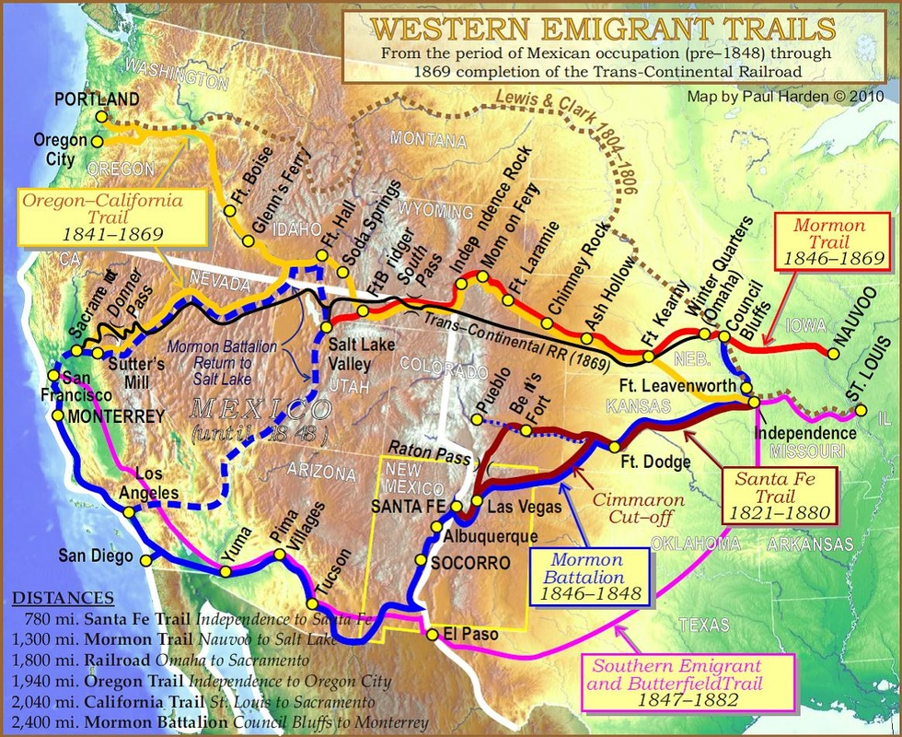

Native Americans on the Plains
In 1840, the Plains were occupied by a diverse range of Native American peoples. One such group were the Lakota. The Lakota are part of a wider group of people known as the Oceti Sakowin (sometimes called the Sioux).
The Lakota were similar to other Plains people like the Cheyenne who also used horses to hunt. However, they were quite different from groups like the Navajo or the Nez Perce who still farmed the land and lived in fixed villages for part of the year.
In 1840, the Lakota lived nomadically on the Plains. They hunted buffalo and had to follow the buffalo herds as they moved around the Plains. Unlike many Southern and Eastern tribes, the Lakota had long since given up farming. Lakota leadership, culture and religion were all based around the importance of relations and living in partnership with nature. The Lakota were highly successful in warfare and had become one of the most powerful forces on the Plains during the early 19th century. Between 1820 and 1860 they pushed other nations such as the Crow and Arapaho further south and east, away from their own homelands in the Black Hills. By the 1840s, the central and northern Plains were dominated by the Lakota and the Cheyenne.

Settler-colonists move west
By 1839 a number things led some white Americans to reimagine their visions of the Plains and the lands in the Far West. Small trickles of emigrants began moving on overland trails to Oregon and California on the West coast. They hoped to find a better life, land, or to convert Indigenous peoples to Christianity. They showed it was possible to build new lives in the Far West. Their colonisation of the West led to the violent removal of many Indigenous peoples.
Life on the overland trails to the West coast was difficult, but this was mostly down to disease, long distances and poorly marked routes. Most encounters with Native Americans were peaceful, with Natives manning ferries or selling supplies. However, the movement of settlers over the Plains had a very negative impact on Plains nations and led to some fighting. The government had to make treaties with tribes like the Lakota so that travellers could pass safely.
Some people did not travel over the Plains but settled on their eastern fringes in places like Kansas or Nebraska. At this point, the Plains were seen as too hostile for most white settlers. Only one group tried to settle on the Plains. The Mormons were a religious group whose vision of the West involved a chance for religious freedom. They moved out to Utah and founded Salt Lake City. Their freedom did not last long, by 1857, the Mormon leader, Brigham Young was forced to hand over control of his new state to the US.

The impact of gold
In 1848, gold was discovered in California in the Far West. This one event cause tens of thousands of Americans (and others) to reimagine their vision of the American West. The California Gold Rush brought over 50,000 Americans, Europeans, Chinese, Mexicans and others to seek their fortune in the Far West. They set up diggings and mining operations, but the real money was made by the entrepreneurs who came out to sell mining equipment or basic supplies. Many people stayed on in California and it became a state in 1850.
The Pike’s Peak gold rush occurred in 1858 in Colorado, in the centre of the Plains. This brought another flood of miners and eventually settler-colonists. People began to reimagine the Plains as a place where white Americans could settle. Cities like Denver were founded. White colonists were now in direct competition with Native Americans for resources. This settlement led to increasing tensions on the Plains.
- Summarise each section of this story using 5-7 bullet points. Make sure you pick out the key details.
- Try one of the following:
  - Take it in turns to tell each other one part of the story. The other person should check how well they do.
  - Record one part of the story in your own words. Share the story as a group so that you all have all of the parts.
  - On your own, create a cartoon strip of the story with speech bubbles and captions.
  - Create a timeline to show the major dates and changes which were happening 1839-60.
- Come back to task 2 in next week and choose another task. Do the same again after 2 weeks.

Chapter 3: Civil War and Reconstruction, 1861-1877
During the 1860s, the USA went to war with itself. The conflict was the bloodiest in US history and settled the question of enslavement in the USA once and for all. Many people have argued that the Civil War and the Reconstruction period which came after it were like a second birth for the American nation.

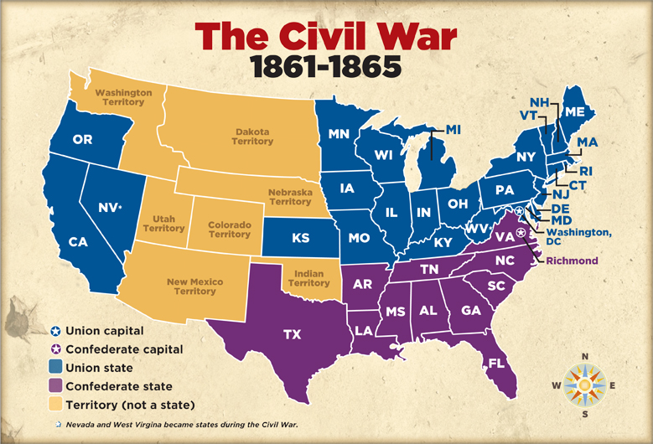
Why was there a war?
Divisions which led to Civil War were already there before 1861. The real question is why war didn’t come sooner. Political divisions played a large role in bringing the war closer. By the 1850s, the North was growing more rapidly than the South; this meant that the North became more politically powerful. Many in the North wanted to end slavery. Northern industrialists did not want to compete with free, enslaved labour and Northern immigrants were also worried that expanding enslavement would take their jobs. Southern slave holders were afraid that they would lose their power and wealth and so they pushed to try and get slavery to expand into new states. Their competing visions of what America should be like brought them into constant conflict in Congress.
Abolitionists (black and white) played a huge role in shifting opinions in the North. They raised public awareness in the North of the abuses of cotton slavery and were active in opposing measures to increase the power of slaveholders. They shifted people’s visions about how acceptable enslavement was, especially in the North.
In 1854 the Kansas-Nebraska Act allowed states to choose if they wanted slavery. This led to a mini Civil War in Kansas. As a result of this the Republican Party were set up. They promised free labour and free land if they won the election. For the first time a single party promised to support one vision of America over another, rather than trying to balance the interests of the two.
In 1860, the Republicans won the Presidential election, the South were not happy. In November 1860 the South began the process of leaving the United States. By the time Lincoln was sworn in, seven states had left the Union and formed the Confederacy. On 12th April 1861, the South opened fire on the North and the Civil War began.

The effects of the war on black Americans
When war broke out it affected black Americans very differently. At the beginning black Americans were not allowed to join the army, even though the North was fighting against slavers in the South. However, as the Union army advanced south in 1861-2, many enslaved people began escaping plantations and joining the Union forces.
In 1863, Lincoln finally passed the Emancipation Edict which freed all slaves in the Confederacy (but not in the slaveholding states who joined the Union). Black regiments were formed in the North and South to fight for the Union. Pay and conditions in these units were not equal.
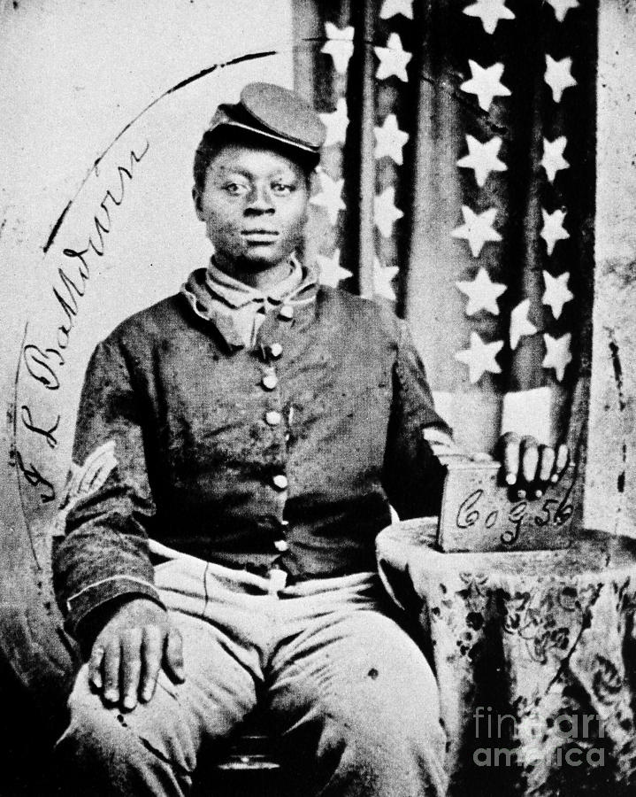
In the Sea Islands, some ex-slaves were given lands to farm. Northerners also came to the South and began setting up churches and schools for the ex-slaves.
As the Union began drafting more troops, race riots broke out in Northern cities. In the South, many freed slaves were put straight back to work on plantations now run by the US army. However, many enslaved people were able to escape brutal conditions. Eventually the Confederacy were defeated; shortly after, Lincoln was shot.

Reconstructing America
After the war there were a lot of questions about what should happen. Black Americans were free, but not yet citizens. There were three main periods in which America was ‘reconstructed’.
During “Presidential Reconstruction”, 1863-5, Andrew Johnson attempted to unite the country. He allowed the South to re-form governments, but these gave black Americans no rights. Some even tried to overturn the 13th Amendment which had abolished enslavement.
The period of “Radical Reconstruction”, 1866-70 was when radical Republicans took control of the project from the President. They had a vision of a truly equal America. They gave black Americans civil and voting rights and banned ex-Confederate officers from voting at all. Southern governments were directly controlled and there was black Americans became active in politics.
After 1870 there was a winding down of efforts to give black Americans more rights. This was because many radical reformers had died, but also because a new generation were more worried about their own wealth than reconstructing the South. Much land was given back to Southern whites and ex-slaves were often forced to start sharecropping. By 1875, black voting rights were being reduced by violent mobs and laws were passed allowing segregation in Southern States. In 1877 the government withdrew troops from the South and left ex-slaves to fend for themselves. By this point, white Americans dominated Southern state governments again.
- Summarise each section of this story using 5-7 bullet points. Make sure you pick out the key details.
- Try one of the following:
  - On your own, create a cartoon strip of the story with speech bubbles and captions.
  - Create a timeline to show the fortunes of black Americans 1860-1877. You should have a vertical axis showing when their lives are getting better or worse.
- Come back to task 2 in next week and choose another task. Do the same again after 2 weeks.

Chapter 4: Conflict in the West, 1861-1877
The Civil War split the USA in half. To help keep people in the North united and supporting the war, Lincoln introduced the Homestead Act and Pacific Railroad Act. These promised Americans a chance to own their own land in the West for no down-payment, and promised a railroad to make their settlement possible. Lincoln wanted to unite the country around a new, Northern vision of America. The increased settlement of the West would lead to more violent conflict, this time with Native Americans on the Plains.

Homesteaders
The Homestead Act was introduced in 1862 and promised US-Americans the chance to own their own piece of land in the West. If they could work the land for a number of years, homesteaders could claim it as their own. This and other factors led large numbers reimagine what their lives could be, and move out onto the Plains.
Living out a vision of Plains life proved to be incredibly difficult due to the lack of building materials, dry climate, lack of access to clean water, and extreme weather. However, it did provide opportunities as women and black Americans were also able to own their own land in the West. Despite their best efforts to deal with the issues of farming the Plains, around half of homesteaders never got to claim their land and headed into cities or back East.

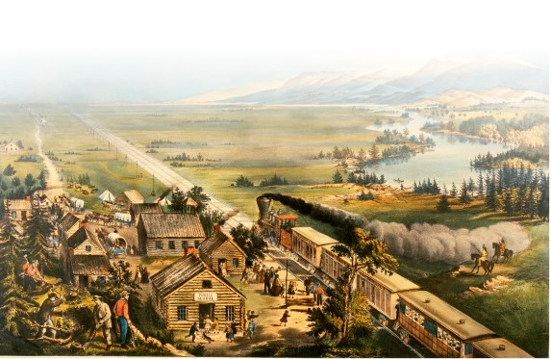
Exploitation: railroads, cow towns and cattle ranches
There were two major railroad companies who began building a route across America: The Central Pacific and the Union Pacific. They were given huge sums of money and vast amounts of land by the government. Both exploited their workers. The Central Pacific for example used huge numbers of Chinese immigrants to blast through the Sierra Nevada mountains. The line was completed in 1869, but most of it had to be rebuilt.
The railroads boosted their profits by selling off the land they had been given. They advertised their Western lands as amazing places for farming – tens of thousands of people moved out to see if the claims were true. The railroads improved trading opportunities in the West. As the railroad lines were built, cattlemen and cowboys would drive huge herds of cattle so they could be sold to markets in the East or to Native American Reservations. This led to the construction of cow towns along the railroad.
Eventually, cattlemen realised that they could make more money if they kept cattle on the Plains rather than driving them to the cow towns all the time. They exploited the availability of “free” grass and water to set up cattle ranches. This brought many into direct competition with Indigenous peoples such as the Cheyenne. Ranchers tended to fence in their water supplies which had a negative impact on Native Americans and homesteaders alike. Their cattle operations led to over—grazing of the Plains.

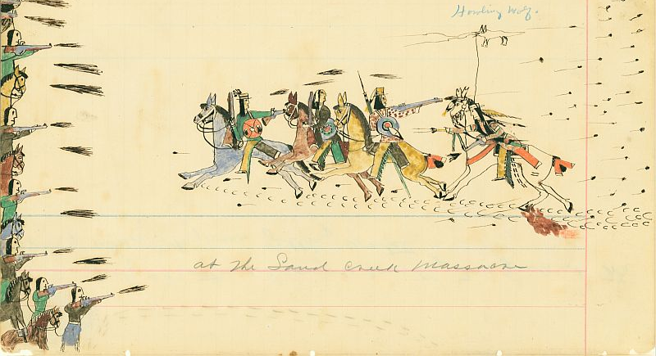
Colonial Wars
In addition to colonising the West, by the 1860s a number of factors were bringing war with Native Americans closer. For instance, many people owned guns thanks to the Civil War; there was a need to unify the white population of America after the Civil War; and there were tensions over access to the scarce water and grass resources of the Plains. Settler colonialism forced different visions of life to come into conflict as resources dwindled away. In 1862, after years of making way for settler-colonists, Little Crow’s Dakota came into conflict with settler-colonists in Minnesota. The army were sent in and Little Crow was defeated. 38 Dakota were hanged in the largest mass execution in US history.
Between 1862 and 1865 tensions continued to rise, particularly in Colorado, where the Pike’s Peak gold rush led to a huge influx of settler-colonists. Cheyenne Dog Soldiers began raiding white settlements, defending their traditional visions of nomadic life. Soon after, a band of unarmed Cheyenne were massacred by Colorado soldiers at Sand Creek. This sparked more violence.
The Lakota, Dakota and Cheyenne joined forces after the Sand Creek massacre. By 1865 the Lakota were becoming increasingly angry at settler-colonists travelling through their territory to seek land and gold in Wyoming. Between 1866 and 1868 Red Cloud, the Sioux chief, fought the colonists and the US army. He was victorious and the Lakota were promised a huge reservation which would be free from US settlement.
However, victory didn’t last long. In 1875, gold was discovered in the Black Hills on the Lakota reservation. Miners flooded in and the US government sent troops to protect them. The government offered to buy the Black Hills, but Sitting Bull and a number of other Lakota chiefs refused. The US army were sent in. They were defeated at the Battle of the Little Bighorn. However the army used railroads to chase and attack the Lakota and their allies all winter. Eventually the majority of Native Americans on the Plains were moved to small reservations and forced to give up their visions of life.
- Summarise each section of this story using 5-7 bullet points. Make sure you pick out the key details.
- Try one of the following:
  - Take it in turns to tell each other one part of the story. The other person should check how well they do.
  - As a group, create a pencil case play of each section of the story. You should each be responsible for one part.
  - On a blank map of America, write on where and when some of the key things were happening.
- Come back to task 2 in next week and choose another task. Do the same again after 2 weeks.

Chapter 5: Who were the Americans by 1900?

Between 1877 and 1900, America tried to turn itself into a stable, modern country. It had grown enormously in size and now wanted to take its seat as one of the world’s great powers.

What happened to the Native Americans?
After 1877 the government made tried to turn Native Americans into American citizens. Most now lived on reservations. Reservations banned traditional ways of life and often forced Natives to accept Christianity and farming. Many Native Americans were forced to move onto reservations because of the destruction of the buffalo. By the 1880s, nearly all the buffalo on the Plains were wiped out, removing a central part of Plains life.
By the early 1880s, groups like Friends of the Indians began campaigning on behalf of the Native Americans. They believed that Natives needed to become US citizens and be protected by the Constitution. They were successful, but Native Americans could only be citizens if they gave up their old lands and accepted 160 acres instead. Vast amounts of Indigenous land went to the government and was sold to white settler-colonists.
Some Native Americans tried to resist peacefully. In 1890, the Ghost Dance movement began. The Ghost Dancers prayed for white Americans to be removed from the land by dancing. The Ghost Dancers were massacred by the army at Wounded Knee. Native Americans continued to survive and resist but it would be the 20th century before any major improvements would occur for Indigenous peoples.

Changes for black Americans
After 1877 many Southern states were brought back into American politics. These states were increasingly dominated by whites who brought in racist laws to stop black Americans from voting. Their vision was restoring the South to a time before the Civil War, when white Americans had been in charge. Jim Crow laws were brought in by the 1890s which segregated facilities in states.
Because they had no land, many ex-slaves and their children were forced into sharecropping arrangements. Sharecroppers rented land from white landowners and paid by giving up a percentage of their crops each year. Many struggled to survive. Poverty amongst the black population, especially in the South, was huge and white Americans held most of the power.
As conditions in the South got worse again, many black Americans moved North, ending up in large cities. Even here, they were discriminated against. In 1877 some black Americans decided to seek their fortunes by moving out West instead: the Exoduster movement was born.
Education for black Americans also got worse after the initial efforts post-war. Segregated schools in the South gave far less money for black students. Some activists set up their own schools for black students. In the North, the situation was slightly better and increasing numbers of black Americans joined the ranks of the most educated.

The growth of big business and cities.
From 1877 onwards the number of corporations grew enormously until they dominated American business. Their vision of America involved huge profits from wealthy business owners. Corporations exploited workers and played them off against each other, especially by using black or Chinese labour to break strikes. The corporations controlled many aspects of working people’s lives through blacklisting and strike legislation.
Cattle ranching on the Plains had largely dried up by the late 1880s and those ranches which did survive were generally sold to meat corporations in Chicago. There were some short conflicts between homesteaders and cattle ranchers over land access, but for the most part too, homesteaders were giving up on farming and heading to the cities.
Cities dominated resources in the West, using their influence to grab land, control trade, and even divert rivers for their own benefit. Most American trade was controlled by big cities and big businesses by 1900.

Immigration
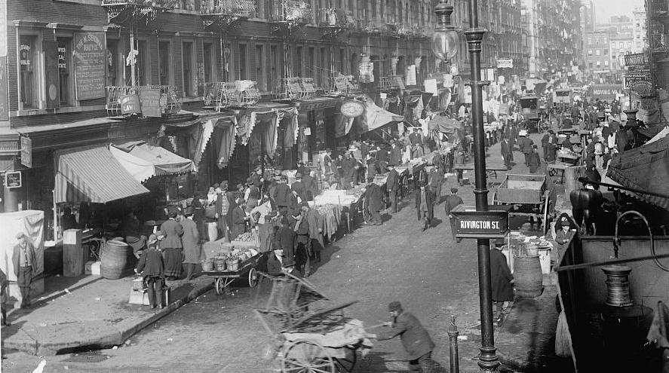
Immigration continued to grow and the US created Ellis Island to process the new waves of immigrants. Immigrants tended to get poorly paid and lived in slum areas. Some immigrants were able to live the American Dream and become rich, however most just lived in poverty.
Lots of people were afraid because the new immigrants were from Eastern and Southern European countries, instead of Northern Europe. Some people said that these new immigrants were “racially inferior.” This led to a lot of violence between working class Americans who were all competing for the same jobs. Soon gang violence and mob culture was beginning to grow.

- Summarise each section of this story using 5-7 bullet points. Make sure you pick out the key details.
- Try one of the following:
  - Create a timeline to show the fortunes of one group of Americans 1877-1900. You should have a vertical axis showing when their lives are getting better or worse.
  - Pick 15 key events from this section and create a set of flashcards. Test a partner using these flashcards (eg. checking the key details, putting them in order etc.)
- Come back to task 2 in next week and choose another task. Do the same again after 2 weeks.

