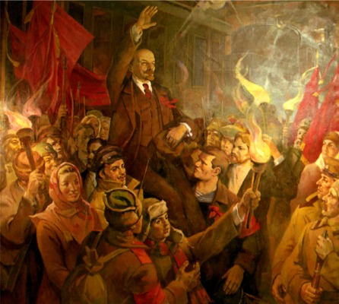
Russia: March – September 1917 (p.90-105)

- Create a detailed, narrative timeline of the key events.
- Complete the task below. Use the table framework if it helps. Make sure you write in enough detail about each aspect.

Event/ Issue | Help or Hinder?  Provisional Government Bolsheviks
Order no.1
The Land Question
The Return of Lenin and publication of the April Theses
The make up of the PG
No elections
The War
The Kerensky Offensive: June 1917
The July Offensive
The Kornilov Coup
The Role of Kerensky

Russia: March – September 1917 (p.90-105)

- Create a detailed, narrative timeline of the key events.
- Complete the task below. Use the table framework if it helps. Make sure you write in enough detail about each aspect.

Event/ Issue | Help or Hinder?  Provisional Government Bolsheviks
Order no.1
The Land Question
The Return of Lenin and publication of the April Theses
The make up of the PG
No elections
The War
The Kerensky Offensive: June 1917
The July Offensive
The Kornilov Coup
The Role of Kerensky

