Russia: Civil War

p.117-129

Tasks
- How did Lenin initially secure the position of the party after the October Revolution?
- Why did Civil war break out?
- Summarise briefly the 4 phases of Civil war.

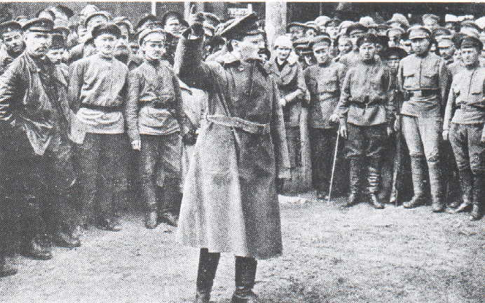

Why did the Communists Win?
Answer the following question:
How significant were the following to the Communist victory?

- The Red Army
- The Geography of the War
- The Red Terror
- Trotsky
- Lenin
- The White Opposition
- War Communism
- Any other relevant factor.

