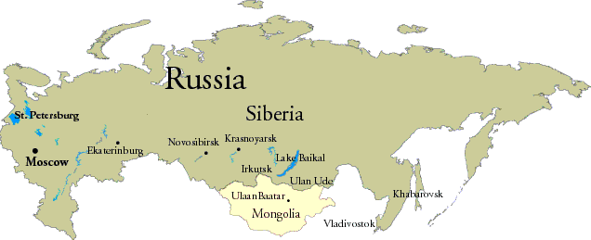

ARCHANGEL MURMANSK LENA TRANS-SIBERIAN RAILWAY

ST PETERSBURG MOSCOW EKATERINBURG PORT ARTHUR

URAL MOUNTAINS VYBORG

