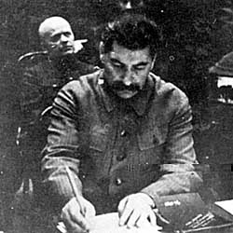
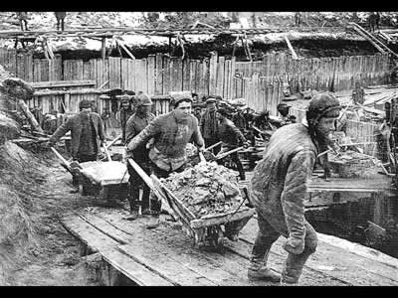
Stalin and Political Power: Explanation of the Purges

Explanations of the Purges

Arguments | Supporting Evidence | Countering Evidence
Stalin planned the purges  This is the traditional view fitting the totalitarian model. This is, Stalin built up massive police machinery with the aim to destroy opposition and submit the population. This explanation implies Stalin totally controlled its direction.  (Deutscher, Fainsod, Mandelstam) | Show trials – After the assassination of Kirov, emergency powers were approved (Law of Dec. 1st 1934). He had the power to arrest and execute without using the courts. However, he insisted on using the show trials. By making them confess publicly he was able to reveal the scale of the conspiracy against him and enable him to prove the need for purging to continue:  - 1936 show trial of Kamenev & Zinoviev accused of wrecking and killing soviet leaders – SHOT!  - 1938 – Bukharin, Rykov, Yagoda – none of the old Bolsheviks held real power – Bukharin blamed Stalin’s morbid suspiciousness  - Of the 1996b delegates at the 1934 congress 1104 were dead within three years  This was a clear message that no one in the party was safe whatever their rank. Stalin used terror as a function to plunge the whole nation into a state of chronic fear to terrify the population to such an extent that it was impossible for any opposition to his rule to be organised. | See details of Kirov’s assassination  Evidence at this stage does not suggest he stage – managed the progression towards terror. In fact 1933 Stalin ordered the release of half the labour camp prisoners and in the summer 1934 ordered that the secret police could not execute without the agreement of the procurator of the USSR. These were not the actions of a man preparing a massive attack on society and planning the Kirov assassination as a trigger for it. Yes, he later used the assassination for an attack on oppositionists because it was useful to him – but there is no evidence to suggest that mass murder was calculated as a part of a grand plan to instigate a wave of terror. It is too simplistic to see terror as arising solely out of Stalin’s ambitions. There was genuine anxiety about failures in the economy, foreign espionage, class enemies and the inability of central government to impose its will on regional party bosses. It was this basic weakness and pressure from Ezhov to use the secret police to remove bureaucrats who were stifling revolutionary enthusiasm that led to the chaotic explosion of violence of 1937 / 38.
Stalin’s Paranoia  This centres on the mental state of Stalin – convinced of plots, espionage, wrecking even amongst those loyal to him.  (Tucker, Medvedev) | This suggests that the root of the terror lay in Stalin’s inordinate vanity and lust for power. The destruction of the old Bolsheviks and those of independent mind enabled Stalin to bring in a new class of government and party officials (Zhdanov, Beria, Khrushchev, Malenkov) who were totally loyal to him. There was no direct evidence of a plot by Marshal Tukhachevsky to betray the USSR to Nazi Germany and launch a coup against Stalin despite some criticism of events of 1936 / 37 and of defence chief Voroshilov. However, even if you accept the counter argument it still does not explain the further purge of 11 War Commissars, 3/5 Marshals, 75/80 SMC, 14/16 Army commanders, half the Navy (all serving Admirals of the fleet were shot) and the purge of the air force which left only 1 senior officer remaining. Loss touch with reality? In light of their security fears, namely Nazi Germany, it would seem so… | The international context contributed to the purges, especially of the army - the rise of Nazi Germany. The show trials coincided with the Nazi move into the Rhineland, Austria and Czechoslovakia. There was a genuine fear of impending war with these ideological opposites – Hitler despised Bolshevism. This may have caused the soviet leadership to remove leaders capable of criticising soviet foreign policy or the conduct of any war. There was also a genuine fear of counter-revolutionary spies in the pay of enemy countries. There was a possibility of leaders like Tukhachevsky – accused of treason in 1937 – launching a coup. So terror in this sense may have arisen out of a genuine desire to protect the revolution not simply Stalin’s own power.
Purges derive from Lenin  Cheka began under Lenin. The precedent for purging was set but was very different in nature to the later terror.  (Arendt, Shapiro, Conquest) | Purging was not new. It was used in 1919, 21, 24, 25, 28, 29. These were attempts to ensure that party members were dedicated and active. If they were from unreliable social origins, e.g. middle class, kulaks, ex white army, they were removed. Terror was used in the civil war, during War Communism and the banning of the political parties in 1922. All these pre-date the Shakhti Trial of 1928 and the 1930s. So there was a tradition of terror and Stalin accelerated a trend already present in Bolshevik rule. | However, terror in the civil war was due to exceptional circumstances when Bolshevik rule was under threat. Stalin’s rule of the 1930s was secure. Before Lenin’s death there was concern about the use of violence against worker and party members. Terror of the 1920s was usually against opponents of the party. During the 1930s it was war against the party itself and against those who had committed no crimes of opposition. Furthermore the purges to 1936 were not acts of terror – they were very different to the mass arrests and executions of 1937 onwards.
There was opposition  Purges were a response to threats and the security of the USSR, the revolution AND Stalin’s own position.  (Shapiro, Bullock) | Industrial Enemies: 1928 Shakhti Trial – Specialists confessed to being spies and saboteurs; 1930 food scientists and bacteriologists shot after confessing to wrecking; half engineers in the Donbass arrested for bourgeois leanings; 1933 Metro-Vickers Trial – accused of being Mensheviks.  Political Enemies: Trotsky in exile ran a suspected network in Russia; Old Bolsheviks (Kamenev, Bukharin, Zinoviev) were of independent mind and had little natural loyalty to Stalin.  Internal Opposition: Central government had the problem of local government officials not carrying out Moscow’s orders – i.e. resisting unobtainable targets. The Riutin Affair;- referred to Stalin as the ‘evil genius of the the revolution’ – Stalin failed to win the death penalty thus suggests he had internal opponents. Within 5 years half the politburo would be dead. Kirov’s assassination??? | Industrial Enemies: Machines broke down and targets were not met but this must be set against the vast numbers of unskilled workers and long hours. This was not sabotage – some may have been spies but it does not explain the execution of many specialists and thousands of others. Stalin may have whipped up terror amongst specialists to increase production.  Political Enemies: The network was for communication purposes not opposition. Old Bolsheviks supported him – Radek, Piatakov and the likes of K, Z & B were no longer close to the centre and there was no evidence of a plot against the leadership.  Internal Opposition: The problem was one of ill-discipline and low quality recruits rather than a plot against the leadership. Stalin could have opted, as suggested by Zhdanov and Kirov, for education and propaganda but chose Ezhov and the purges. The Riutin Affair could be explained as an example of the principle collective leadership rather than opposition.
Series of Reactions  This was not a united leadership but one struggling with the lower ranks of the party blocking or manipulating instructions. Therefore the purges were a desperate reaction to this.  (Lewis, Acton, Nove) | The purges indicate the weakness of the soviet government up to 1937. Government was frustrated with the way the party was organised. Membership records were in disarray and undesirable people had got into the party in order to protect themselves and to advance their ambitions. Each of the purges had failed to resolve this. To the leadership the reason was clear – local party secretaries refused to reform the party. They looked after their own allies and purged innocent members instead of responding to central government directives to improve party efficiency. So the purges 33 – 36 far from demonstrating Stalin’s power revealed the inability of the leadership to control the party. Thus such a sense of weakness encouraged a radical solution to the problem.
Other leaders and agencies helped create and shape the purges  Stalin delegated internal security to Yagoda and Ezhov. That is the NKVD took initiative. Stalin later suggested that the NKVD had gone too far.  (Arch-Getty, Manning, Rittersporn) | NKVD under Yagoda, later Ezhov was a law unto itself. Yagoda wanted to make factory managers scapegoats for problems in industry. Ordzhinikidze aimed for realistic targets and resisted Yagoda. Radical leaders (Ezhov) wanted faster change. He believed the problems were the result of class enemies deliberately trying to wreck the USSR. 1936 saw Stalin shift position to back the radicals. This resulted in the arrest of Piatakov, Radek. Explosions in Siberian Kemerovo pits saw Yagoda replaced by Ezhov. So a personal intervention by Stalin – Ezhov a less scrupulous and vicious man – whose name became a by-word for terror (Ezhovschina). What now followed was a mass campaign by the secret police hunting out enemies of the people. Arch-Getty refers to a ‘maelstrom of political violence’ – an irrational killing spree. Ezhov set police quotas for arrests and equated faction with counter-revolution. The army became a catalyst – suddenly bad work, incompetence, errors equalled wrecking and was thus considered treason. NKVD under pressure to meet these targets. Those arrested were actively encouraged to denounce others. This despite Stalin’s calls to avoid a witch-hunt.
The purges took on a life of their own  Soviet citizens denouncing the neighbours, workmates and families. In this sense the purges infected society and gained a momentum of their own from ‘below’ as much as above.  (Brezinski, Cohen) | Ordinary people criticised and denounced those above them. Events ran out of control. Stalin declared that grumblers were enemies. NKVD awarded informers with a share of the victim’s property. People used denunciation to settle scores and eliminate rivals. Once started the process took on a life of its own. What had begun as a bloodletting within the party soon engulfed the whole nation in two years of chaos and increasing paranoia. In this sense the terror’s energy came from below as much as above. In this purge 1/18 of the population was arrested. Almost every family in the USSR suffered the loss of at least one member as a victim of the terror.
Conclusion
So Stalin did not single-handedly plan a policy of terror. He must take responsibility for turning a tense situation into massive violence. It was Stalin that reopened Kirov’s murder in 1936; he allowed condemnation of Piatakov; in June 1937 he backed Ezhov and the NKVD and the hunt for wreckers. He encouraged the idea that wreckers were infiltrating the USSR. Archives show Stalin’s signature on 366 death sentence lists totalling 44 000 people in 1938 alone. Elimination of many did create a second generation of Stalinists – Zhdanov, Malenkov, Beria and Khrushchev who would be loyal to him rather than adhere to Lenin’s principle of collective leadership. The logic of personal motive cannot account for the wider terror of 1937 / 38. Yes he signed many death warrants in a day, but he cannot have heard of more than a fraction of his victims – virtually none a threat to him.
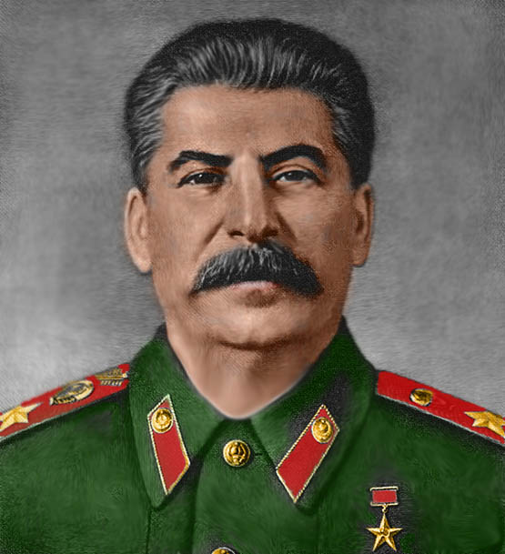
The Positives and Negatives of the Purges
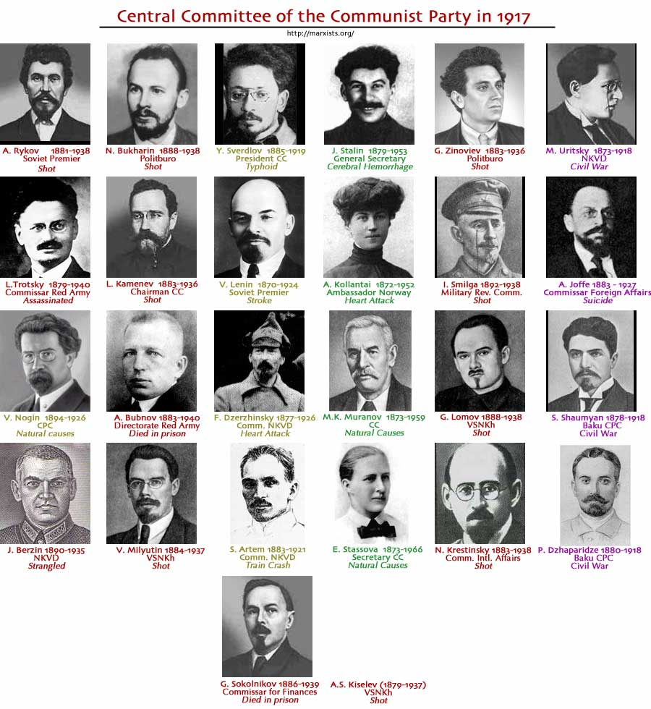
Positive | Negative
- Consolidated Stalin’s position. Only he could be relied on to stand above the web of treachery  - Created second generation of Stalinists who would serve as loyal functionaries  - Provided scapegoats to cover up failures – especially economic  - Provided vital slave labour to open up the remote East – vital in the later fight against Nazi Germany  - Created job opportunities – Promotion! | - Trial of engineers, managers and intellectuals harmed economic growth and contributed to the economic slump of 1937  - Loss of bureaucrats meant that administration was disrupted and this loss of skills caused chaos in planning and industrial production  - Military: Red Army leadership was decimated. “The terror broke the backbone and brains” of the military. This would be catastrophic given the 1941 invasion on the USSR by Nazi-Germany  - Slave labour inefficient – thousands died needlessly  - Up to 10 million died in the purges and labour camps  - Turned Russia into a flock of trembling sheep  - When discovered it ruined the image of communism  - Decimated the nation and party elite  - Stalin destroyed and betrayed the revolution  - Eliminated the very notion of non-subversive disagreement (Nove)  - Party became monolithic. The terror stifled the creative discussion of the 1920s over how to solve Russia’s problems
The Positives and Negatives of the Purges

