Q1.
* | 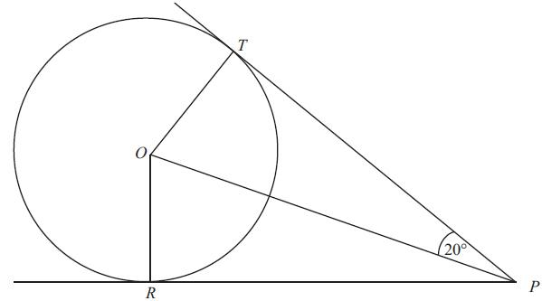 | Diagram NOT  accurately drawn
d dT and R are two points on a circle centre O. PT and PR are the tangents to the circle from P. Angle TPO = 20°. Work out the size of angle TOR.
You must give reasons for each stage of your working.

(Total for Question is 4 marks)

Q2.
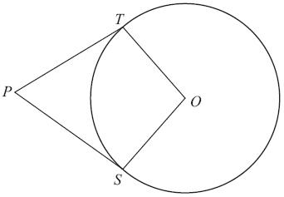 | Diagram NOT  accurately drawn
S and T are points on the circumference of a circle, centre O.
PT and PS are tangents.
Angle TPO = 24°.
Work out the size of angle SOT.

. . . . . . . . . . . . . . . . . . . . . .°
(Total for Question is 3 marks)

Q3.
* | 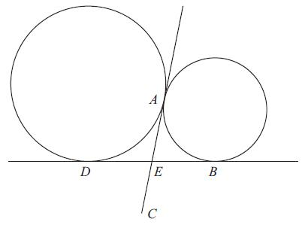 | Diagram NOT accurately drawn.
d dA and D are two points on the circumference of a circle.
A and B are two points on the circumference of a smaller circle.
DB and AC are tangents to both circles.
E is the intersection of DB and AC.
E is the midpoint of AC. Prove that ABCD is a rectangle.

..............................................................................................................................................
(Total for Question is 4 marks)

Q4.
* | 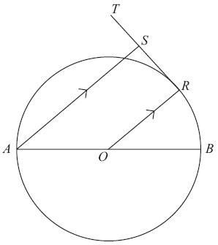 | Diagram NOT  accurately drawn
d dAB is a diameter of a circle centre O.
The point R is on the circumference of the circle.
RST is the tangent to the circle at R.
AS is parallel to OR. Prove that the size of angle AST is 90°.

(Total for Question is 3 marks)

Q5.
Question  %%% |  | Working | Answer | Mark | Notes
* |  | 180 –(90 + 20) = 70 2 × 70 = 140  (180 – 40)÷2 =70  180 – 2×(90 –70) = 140 | Angle TOR =140° | 4 | M1 for angle PTO (PRO) = 90° or seeing it marked on the diagram with a right angle or as 90°  M1 (dep) for 180 –(90 + 20) (=70° ) or for 360 – (90 + 90 + 40) (=140)  A1 for (angle) TOR = 140° or for 140° seen in the correct place in the diagram  [140° alone without the 'TOR =' gets A0]  C1 (dep on at least M1) for angle between a tangent and a radius = 90° plus at least one other correct reason from:  Sum of angles in a triangle is 180°  Sum of angles in a quadrilateral is 360°  TrianglesPTO and PRO are congruent  Tangents from a point are equal in length  OR M1 for angle PTO (PRO) = 90° or seeing it marked on the diagram with a right angle or as 90°  M1 for (180 – 40)÷2 (=70) and [180 – 2×(90 –"70")] (=140)  A1 for (angle) TOR = 140° or for 140° seen in the correct place in the diagram  [140° alone without the 'TOR =' gets A0]  C1 (dep on at least M1) for angle between a tangent and a radius = 90° plus at least one other correct reason from:  Sum of angles in a triangle is 180°  Base angles of an isosceles triangle are equal  TrianglesPTO and PRO are congruent  Tangents from a point are equal in length

Q6.
Question  %%% |  | Working | Answer | Mark | Notes
 |  | Angle PTO = angle PSO = 90  Angle TPS = 24 × 2 = 48  360 – 90 – 90 – 48 OR Angle PTO = 90  Angle TOP = 180 – 90 – 24  = 66  66 × 2 | 132 | 3 | M1 for angle PTO = 90 or angle PSO = 90, could be marked on the diagram  M1 for 360 – 90 – 90 – (24 × 2)  A1 cao OR M1 for angle PTO = 90 or angle PSO = 90, could be marked on the diagram  M1 for 2 × (180 – 90 – 24)  A1 cao

Q7.
Question | Working | Answer | Mark | Notes
 | DE = AE, and AE = EB  (tangents from an external point are  equal in length)  so DE = EBAE = EC (given) Therefore AE = DE = EB = EC  So DB = ACIf the diagonals are equal and bisect each other then the quadrilateral is a rectangle.  OR If AE = DE = EB = EC  then there are four isosceles triangles  ADE, AEB, BEC, DEC in which the angles  DAB, ABC, BCD, CDA are all the same. Since ABCD is a quadrilateral this makes all four angles 90°, and ABCD must therefore be a rectangle. | Proof | 4 | B1 for DE = AE or AE = EB(can be implied by triangle AED is isosceles  or triangle AEB is isosceles  or indication on the diagram) OR tangents from an external point are equal in length  B1 for AE = DE = EB = ECB1 for DB = AC, (dep on B2)  OR consideration of 4 isosceles triangles in ABCDC1 fully correct proof.  Proof should be clearly laid out with technical language correct and fully correct reasons

Q8.
Question  %%% |  | Working | Answer | Mark | Notes
 |  | Angle ORT = 90°  Angle between the tangent and the radius is 90°  Angle AST = 90°  Corresponding angles with angle ORT as AS is parallel to OR | Proof | 3 | B1 for angle ORT (or angle ORS) = 90°  C1 for angle between the tangent and the radius is 90°/right angleC1 for angle AST = 90° and angle AST = angle ORT because corresponding angles are equal oe or for angle ASR= 90° because of allied /co-interior angles, so angle AST = 90° because angles on a straight line add up to 180°

