**Parts of a castle!**

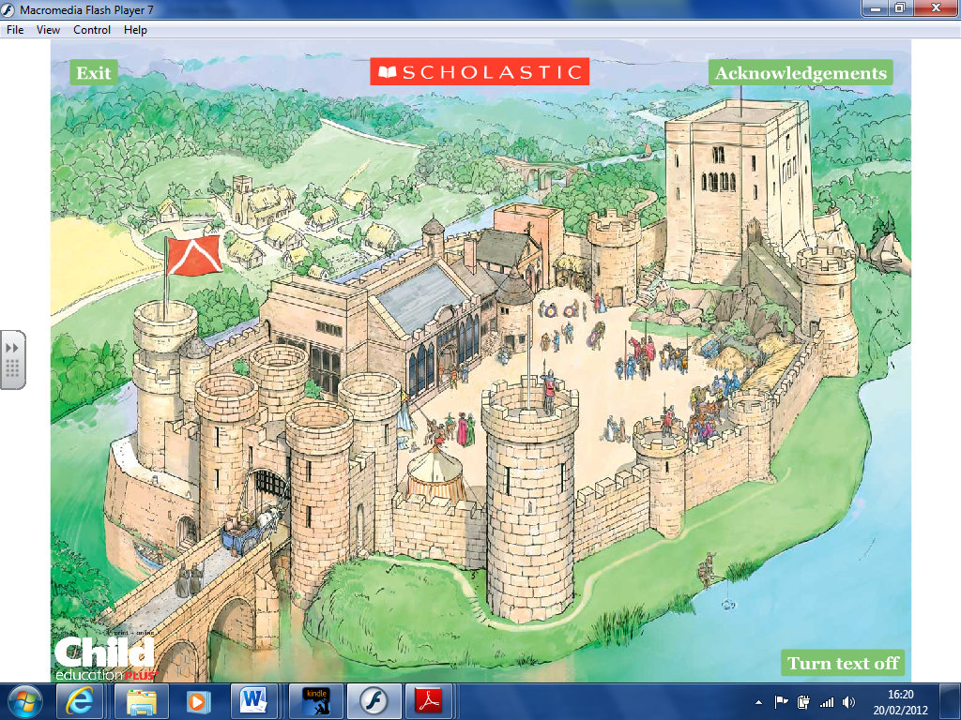

Keep

Curtain wall

Moat

Gatehouse

Crenulations

Arrow slits

Portcullis

Tower

Word bank: Tower Moat Keep Curtain wall

Crenulations Gatehouse Portcullis Arrow slits

**Parts of a castle!**

Extension Task!

On the back of your sheet write down as many buildings you can think of that would be inside the curtain wall.



Word bank: Tower Moat Keep Curtain wall

Crenulations Gatehouse Portcullis Arrow slits