Britain 1500-1750

What Changed?

Britain in 1500 was still recognisably medieval; most people worked in agriculture, towns were small, building design had undergone no radical change and technology and transport had changed little. *However, by 1750, there had been some significant development in these and other areas.* Fill in the gaps on the picture key using the words at the bottom of the page.

1. New industries were developing such as ___________ mining and textile manufacture shown by the new multi-storey ___________ .
2. __________ power was now a new source of energy indicated by the large cast iron _________ (which also shows the growth of the iron industry to manufacture such items.)
3. Towns were beginning to expand and housing was now more ___________________ and better designed using new manufactured materials such as ___________________.
4. Farming, although still not mechanised, was more efficient and produced more food through the use of ___________________ and the growth of private farms.
5. Transport was now improving through the use of _____________ on __________________ to carry farming and industrial goods around the country and passengers were benefitting from speedier travel on ____________________ on the improved ________________ roads and bridges.
6. Clothes were becoming both more practical and decorative (as well as more comfortable) with the introduction of _____________, linen and ______________ so replacing the monopoly of wool.

*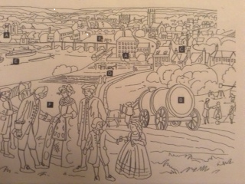Enclosures factory turnpikes brick steam substantial silk boiler stagecoaches barges coal cotton canals*