**What does Guild Chapel tell us about the importance of religion in medieval society?**

**Starter**

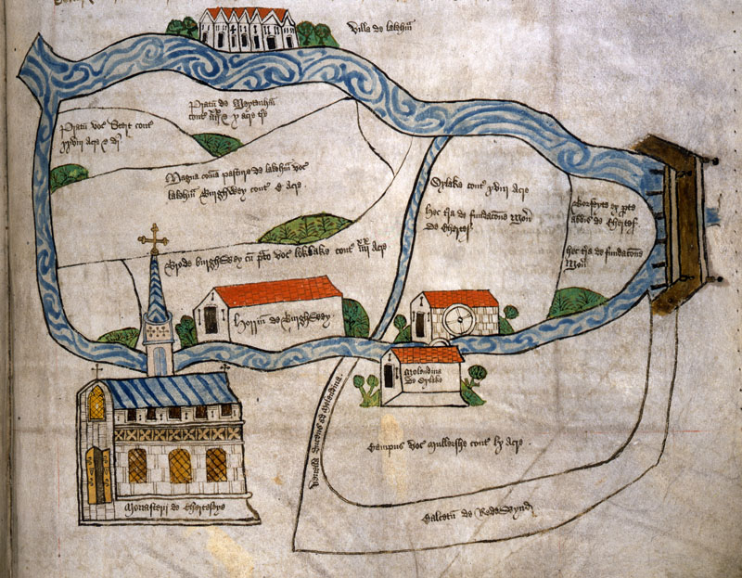

This image is of __________________________________________________________________________

The biggest building on the map is ___________________________________________________

This tells us that religion in the medieval period ___________________________________

______________________________________________________________________________________________

______________________________________________________________________________________________

______________________________________________________________________________________________

* **The Church played a far _________ role in Medieval England than the Church does today.**
* **The Church ___________everybody’s life.**
* **All medieval people – be they ________ or _____ people – believed that God, Heaven and Hell all existed.**
* **From the earliest ages, the people were taught that the only way they could get to ________was if the Roman Catholic Church let them.**
* **Therefore people would do anything to ______the church**
* **Everybody would have been _________of Hell and the people would have been told of the sheer horrors awaiting for them in Hell in the ________ services they attended.**